# Protocol for using tools to quantify white matter hyperintensity volumes from FLAIR MRIs in the absence of other imaging sequences

James Stefaniak, The University of Manchester

1. Create a single 3D image file from individual 2D slices:

Individual FLAIR MRI slices are often provided as separate 2D dicom files. These need to be converted into a single 3D IMG file for use by the tools. To do this using MRIcro (image software that is freely available online): ‘Import’->’Convert foreign to Analyze’, enter the number of slices (2D dicom images) within the 3D image, then click ‘Select’ and select the first file in the image’s folder.

1. uom_overlay_editor

Open the ‘uom_overlay_editor’ .exe application. Then open the 3D FLAIR IMG file just created in step 1. Different slices can be viewed using A/Z keys. The ‘N’ key can be used to display the full voxel intensity range. ‘uom’ is then used to create a mask overlaying all white matter hyperintensity (WMH) present in the 3D FLAIR image; this is done quite simply by clicking on a coloured square in the bar along the left of the screen then clicking on regions of WMH on each slice. ‘uom’ has two methods to speed up such lesion segmentation.

1. Growing the lesion method for segmenting discrete WMHs

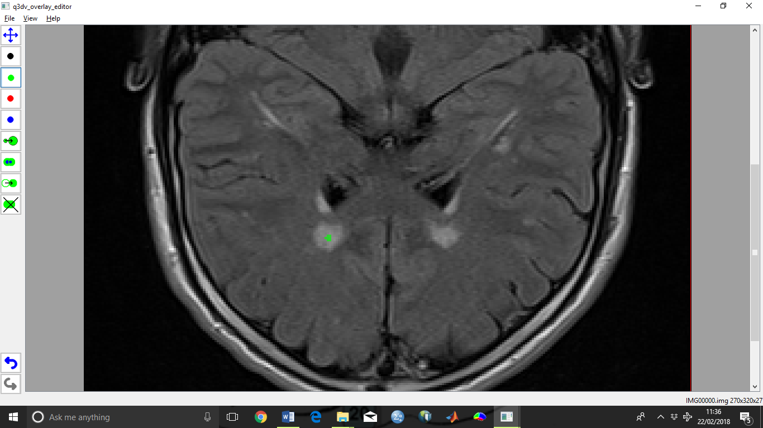Some WMHs are discrete. In order to create a lesion mask for discrete WMHs, click on a coloured square in the bar along the left of the screen and click inside the discrete WMH.

Then select ‘Set GrowBlob Mode’ and click on the mask until the coloured segment has expanded sufficiently to fill the discrete WMH.

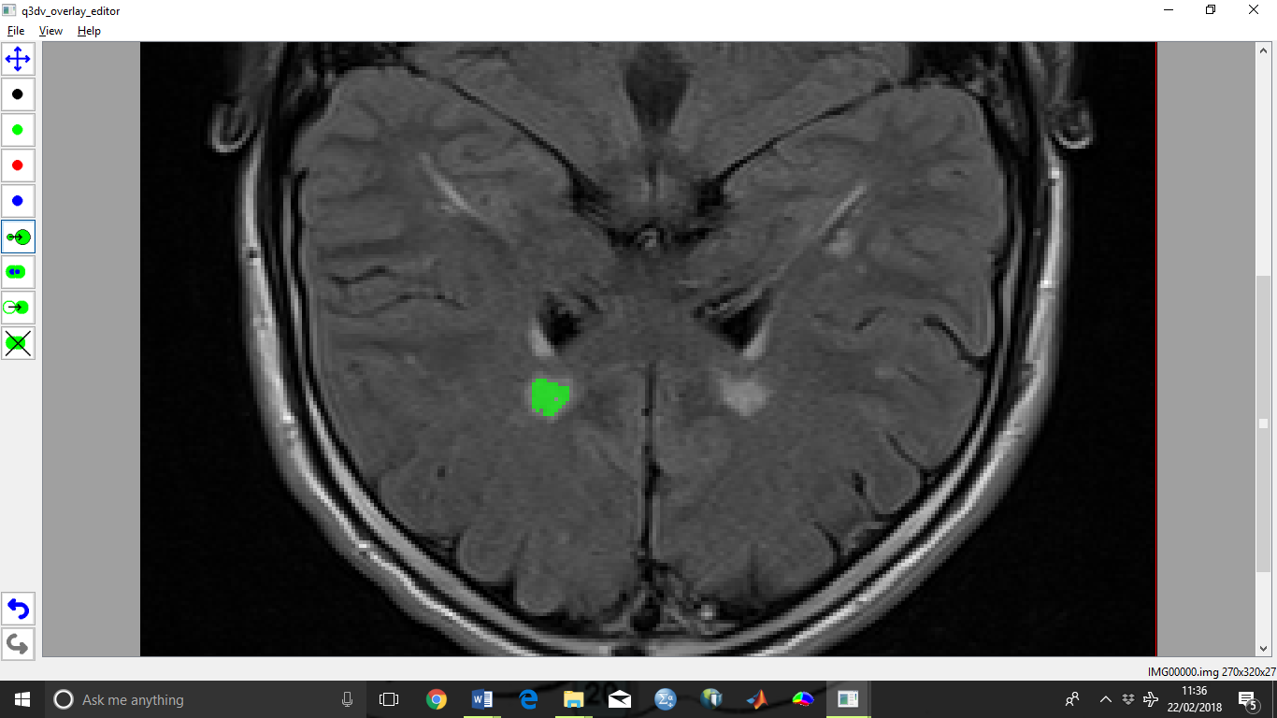

1. Thresholding method for segmenting diffuse WMHs

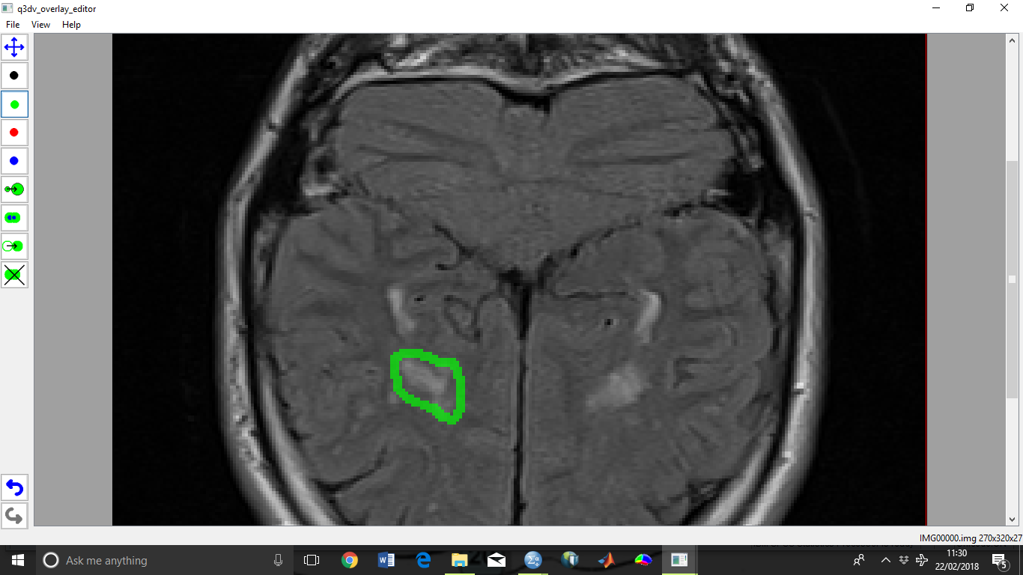Some WMHs are diffuse with patchy areas of non-WMH inside them. In order to create a lesion mask for diffuse WMHs, click on a coloured square in the bar along the left of the screen and draw a circle around the area of diffuse WMH.

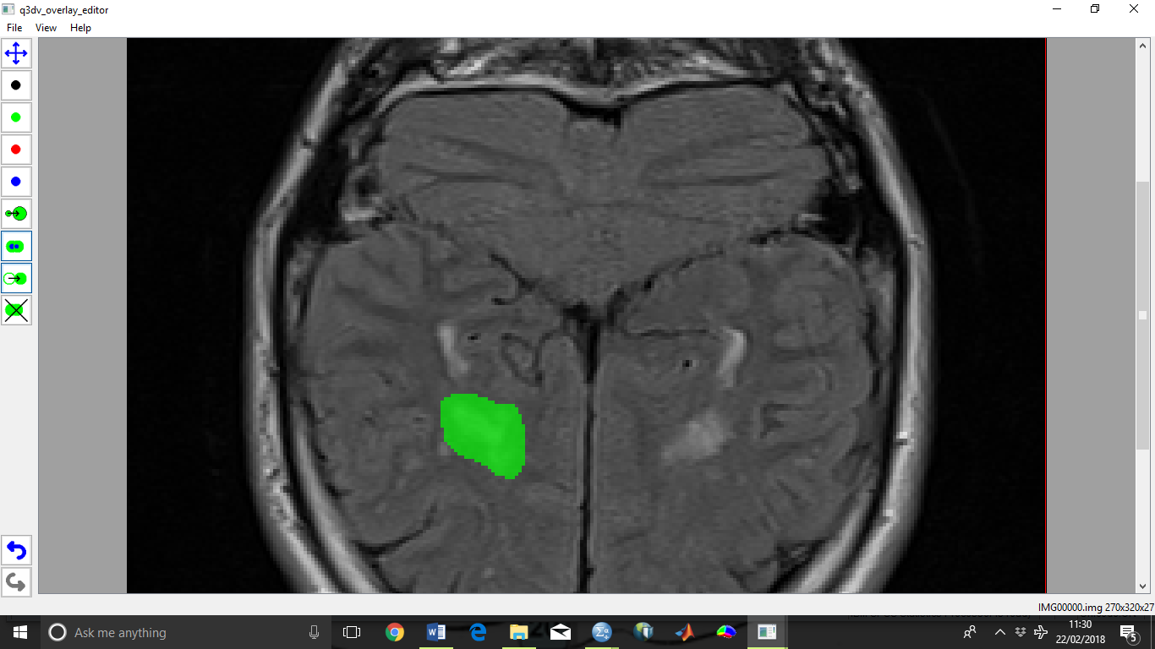Then select ‘Set FillBlob Mode’ and fill in the circle around the area of diffuse WMH.

Then select ‘Set Threshold Blob Mode’, click and hold inside the coloured segment, and drag the mouse left or right to change the threshold until you are satisfied that the differently coloured inner segment covers the region of diffuse WMH. Repeat this for all diffuse WMHs within that slice.

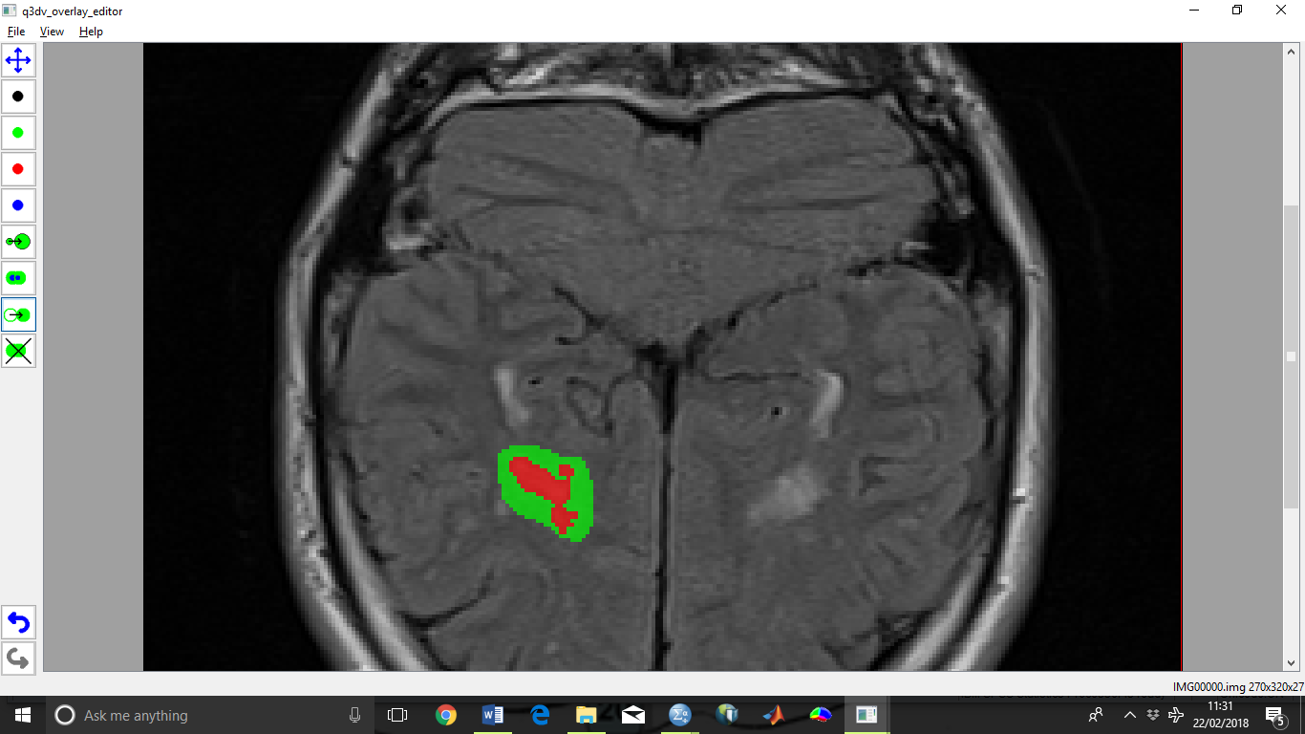

Then right click on the image and delete the outer colour in each coloured segment.

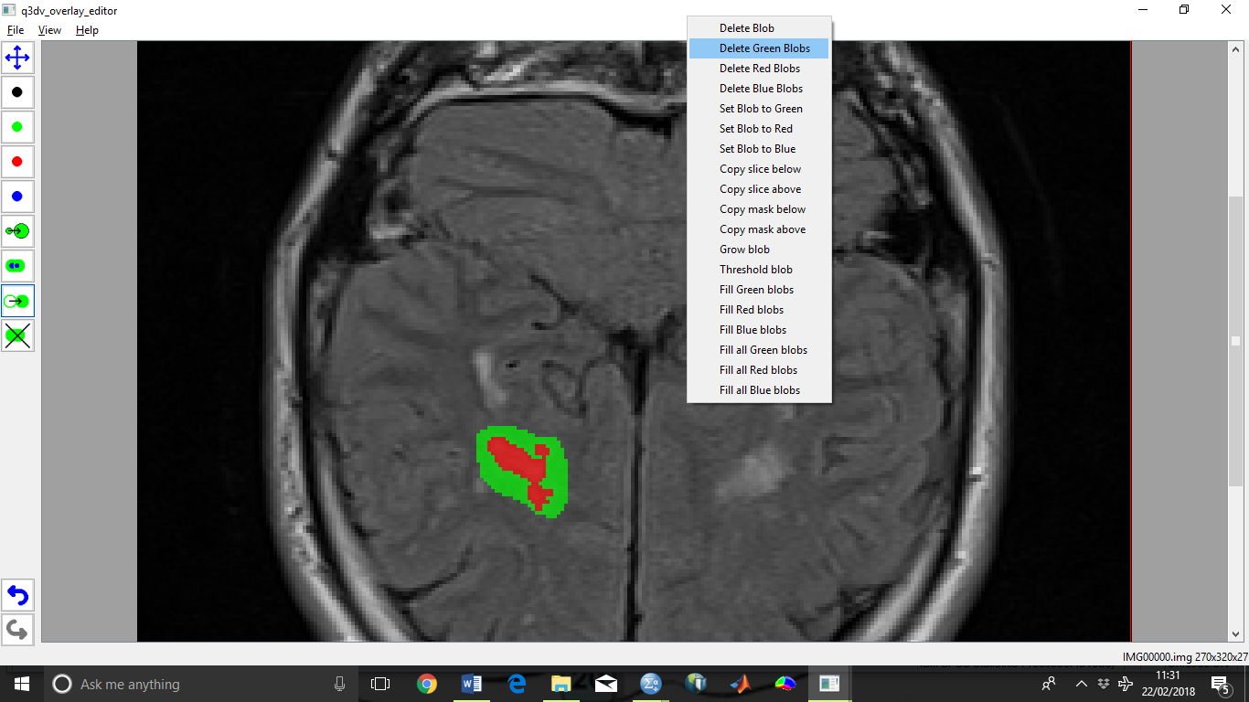

The differently coloured inner segment will remain and is the lesion mask.

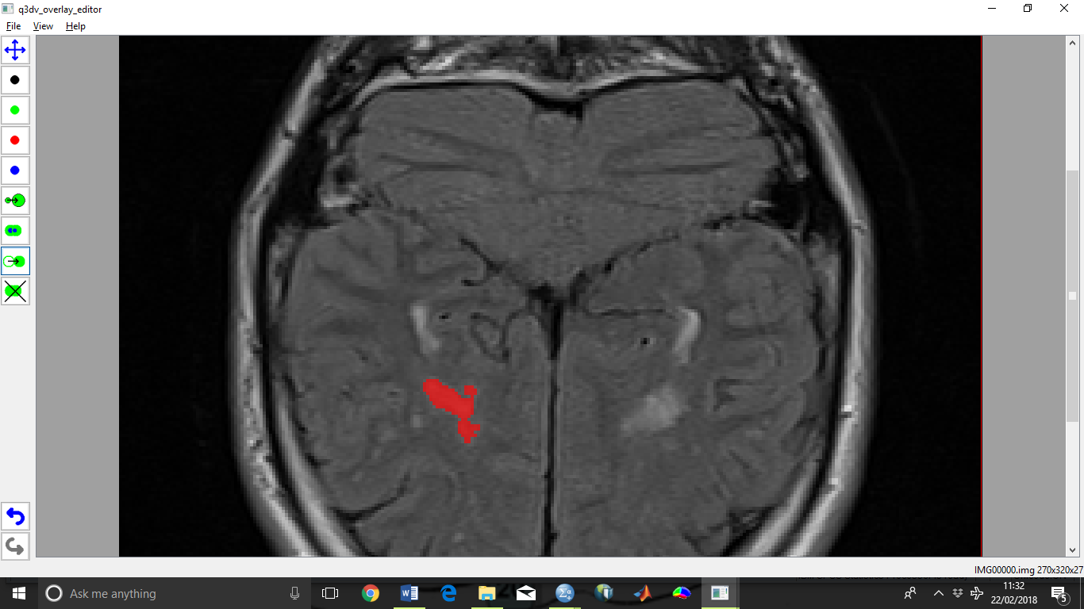

1. Create a lesion mask for each slice in the FLAIR MRI

Different slices can be viewed using A/Z keys.

1. Save the lesion mask

Click ‘File->Save Overlay’. Save the file name with ‘.v3i’ as the ending.

1. Move the lesion overlay ‘.v3i’ file and ‘roam_label_image_histo.exe’ application from the ‘uom_overlay_editor’ folder into a new folder
2. Use the command line to run the ‘roam_label_image_histo.exe’ application

For instance, in a Windows operating system, click ‘Start’->’Run’ and enter ‘Command Prompt’. Navigate to the new folder containing the new ‘.v3i’ lesion mask file and ‘roam_label_image_histo’ application using the ‘cd’ command to change file directory (e.g. ‘cd ..’ to move up a directory, ‘cd [insert folder name]’ to move into a sub-directory). Once inside the new folder, run the following command:

roam_label_image_histo -i overlay_image.v3i -o label_histo.txt

Where ‘overlay_image.v3i’ should be changed to the name of the ‘.v3i’ lesion overlay file.

1. label_histo.txt is the name of the output file created in the new folder, which might look like this:

0 934838  
1 345  
2 0  
3 0  
4 0

The first number column is the label (0=background, 1=green, 2=red, 3=blue) and the right number column is the number of voxels in the image with the value. For instance, in the numbers above, the background contains 934838 voxels, and the green lesion overlay you have created contains 345 voxels.

1. Convert the number of voxels into a volume

To convert the number of voxels to a volume, you need to calculate the volume of each voxel in the FLAIR image. For instance, using ‘MRIcro’, open the FLAIR image, click ‘Import’->’Display/hide foreign header’, where you can find the voxel dimensions (x, y and ‘slice thickness’ for z) in mm. Multiply these dimensions to produce the size of each voxel in mm3, then multiply the volume of each voxel by the number of voxels in the WMH lesion overlay mask to produce the WMH volume.