Digital Rocks for Geo-energy & Geo Storage
Dr. Lin Ma’s research Group
Home | Research Themes| Projects | Publications | Contact

Multi-scale Imaging and Characterisation

Research interest:
- Multi-scale characterisation (3D)
- Pore quantification and upscaling
- Dynamic imaging (4D)
- Image and image-based modelling
- Fracturing and flow behaviours
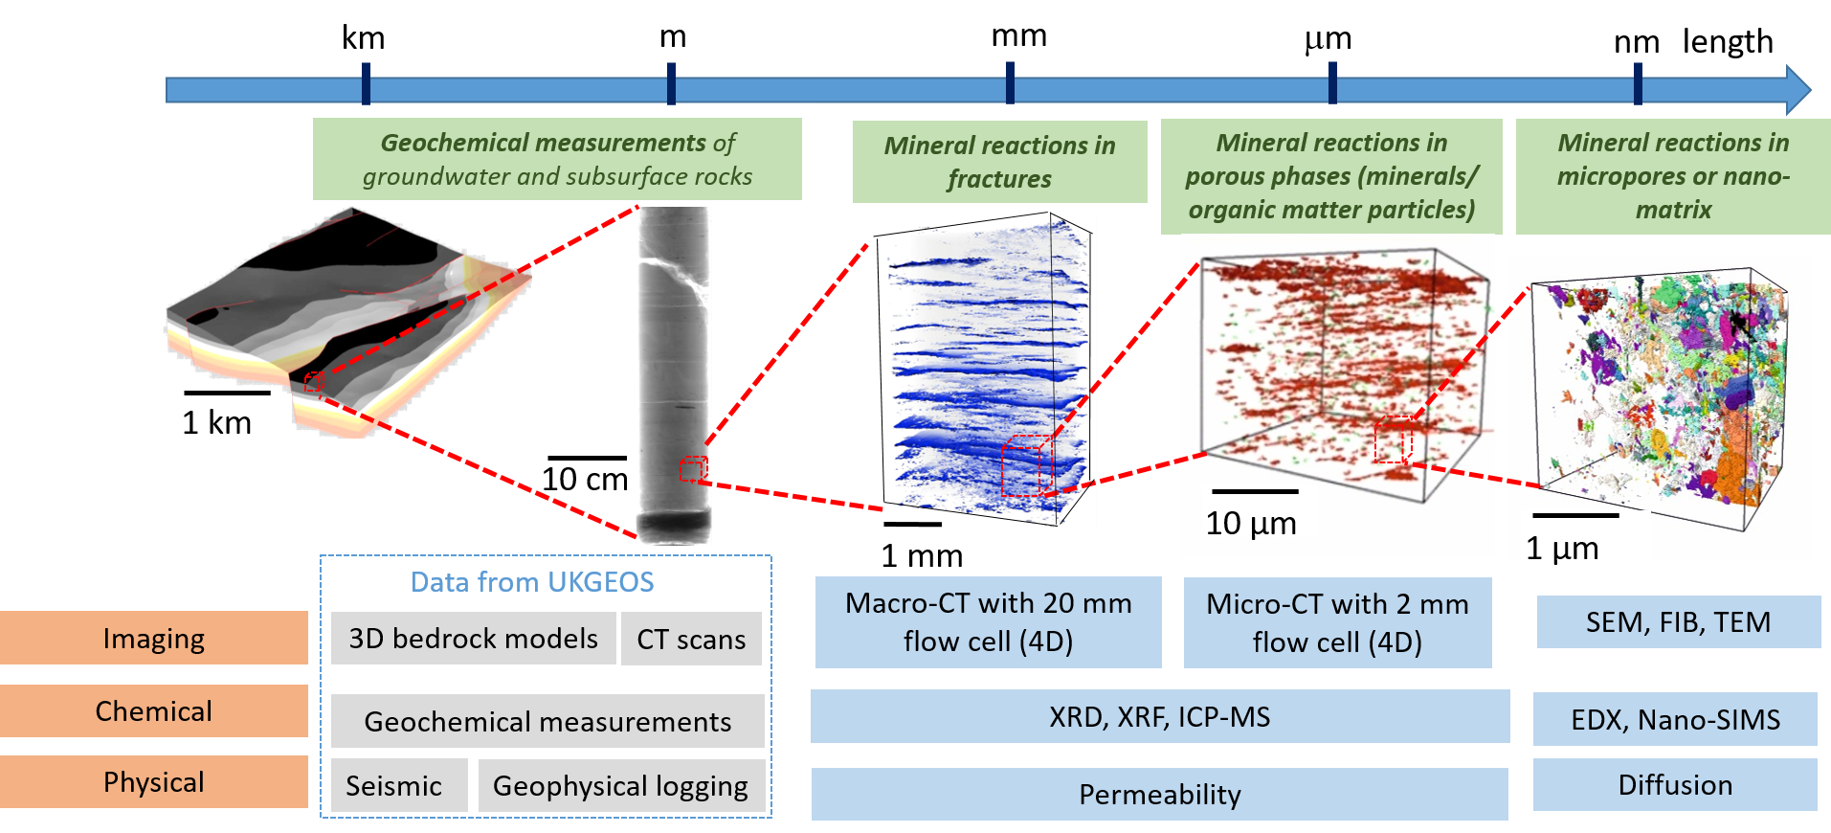
Research applications:
- Hydrocarbon reservoirs
- Subsurface gas storage
- Carbon sequestration and storage
- Geothermal and subsurface heat storage
- Nuclear waste disposal
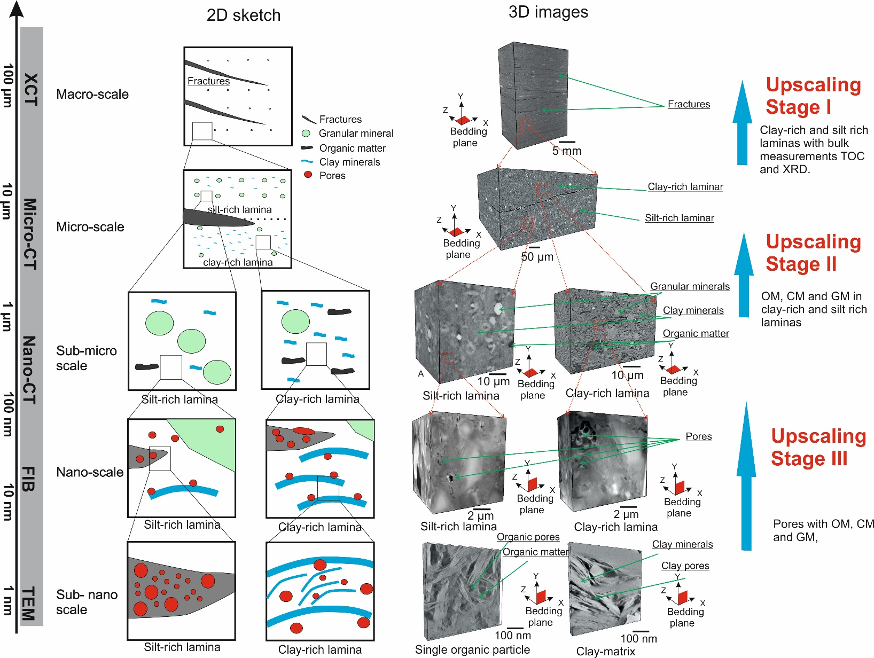
Contact: Lin.ma@manchester.ac.uk

