_________________________________________________________________________________

Tissue Engineering Bone Tissue Engineering Lecture 7 21/10/04
_________________________________________________________________________________

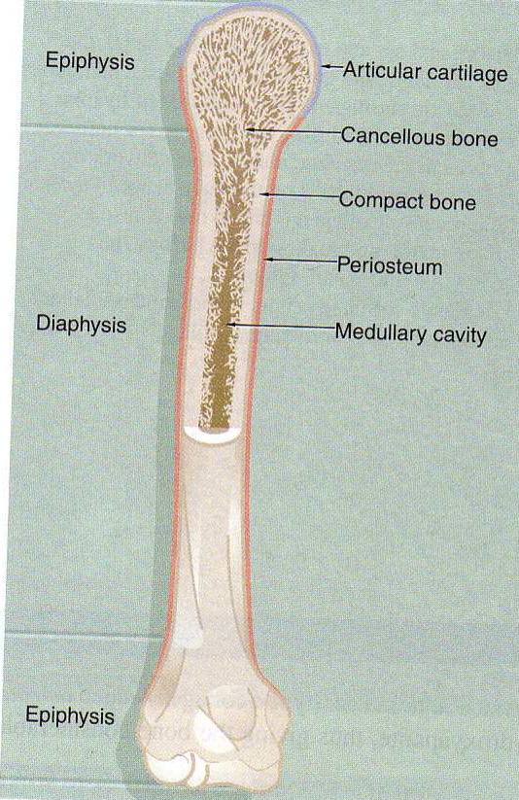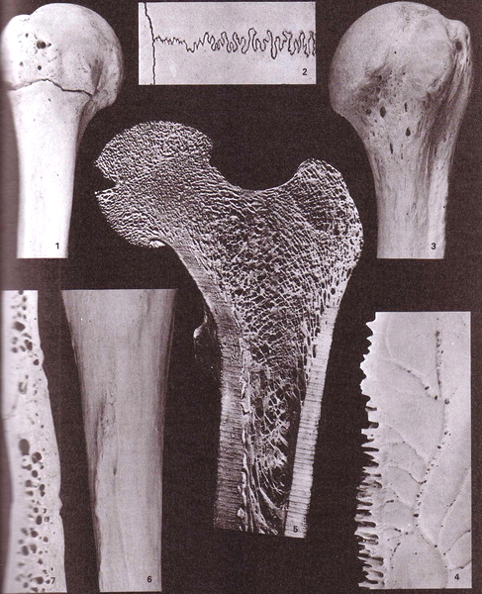

general structure of long bone in mature skeleton
compact bone forms the dense walls of the shaft of the diaphysis
cancellous bone occupies the central medullary cavity which is a network of fine irregular plates called trabeculae separated by intercommunicating spaces.
In immature animals the medullary cavity contains active bone marrow responsible for the production of the cellular elements of blood. In the adult active marrow is restricted to a few sites.
The external surface of the bone is covered by periosteum into which the muscles insert aswell as tendons and ligaments. Inner surfaces are covered by endosteum.
Periosteum and endosteum are the bone forming areas, remodelling and where fractures are fixed.

macroscopic features of bone structure
1. anterior aspect of the proximal end of an immature humerus
contrasting surface characteristics of the smooth articular surface
2. external aspect of part of the sagittal (horizontal) and coronal (vertical) cranial sutures. Variation in form and degree of interlocking of bones
3. anterior aspect of the proximal end of a mature humerus. Complete osseous fusion (compare to 1). Variations in surface texture.
4. endocranial aspect of the sagittal margin of a parietal bone. Highly complex nature of the sutural surface. Vascular grooves, multiple vascular foramina on the endocranial surface.
5. coronal section through the head neck and greater trochanter and proximal shaft of an adult femur clearly showing the variation in thickness of the shell of compact cortical bone and the organization of the bony trabeculae.
6. posterior aspect of part of the shaft of a tibia. Relatively smooth areas which bear “fleshy” attachments of muscles, the ridge where dense lamellae of collagen are attached and an oblique vascular foramen which transmits the main nutrient vascular bundle to the shaft.
7. sectioned bone of the cranial vault showing the internal and external tables of compact bone separated by the trabecular diploe, the diploic spaces of which in life are filled with haemopoietic red bone marrow.

Trabecular bone at different sites of a femur

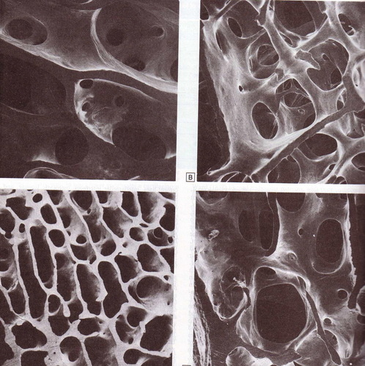
trabecular bone at different sites in the proximal part of the same human femur.

A. subcapital part of the neck
B, C greater trochanter
D rim of the articular surface of the head.

Wide variation in the thickness, orientation, and spacing of the trabeculae.

Main features of the blood supply of a long bone

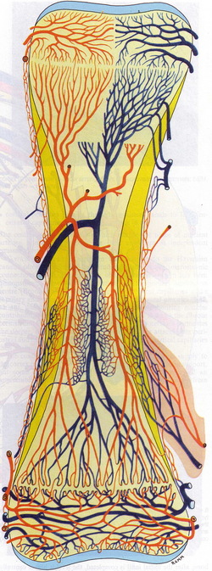

main features of the blood supply of a long bone.

Contrasting supplies of the diaphysis, metaphysis, epiphysis

and their connections with periosteal, endosteal, muscular and periarticular vessels

Compact bone
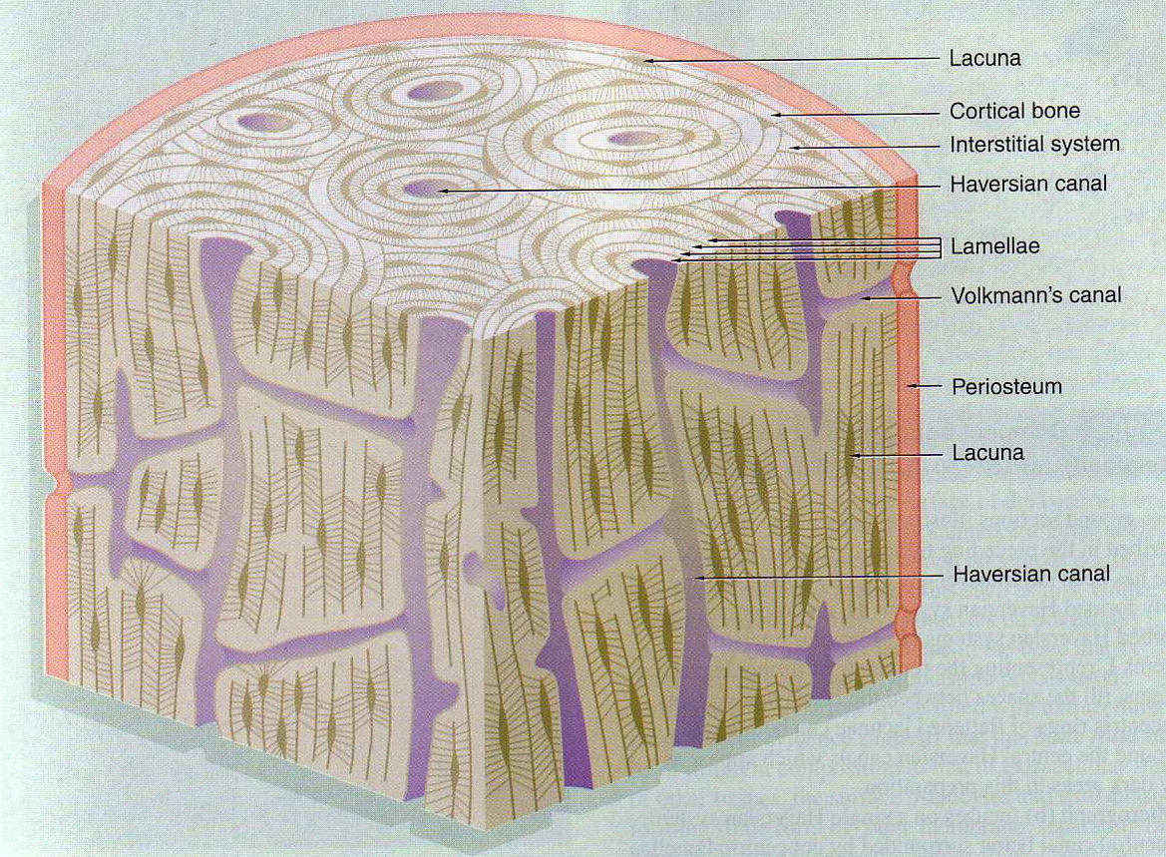
made of parallel bony columns which are parallel to the long axis of the long bones i.e. the line of stress exerted on the bone.
Each column is made of concentric layers of lamellae around a central channel containing blood vessels, lymph vessels and nerves.
Neurovascular channels are called haversian canals
Volkmanns canals are where the neurovascular bundles interconnect with one another and with the endosteum and the periosteum.
Osteoblasts lay down bone in a broad channel, as the bone is formed the diameter decreases and the osteoblasts get trapped and become osteocytes in the lacunae. Canaliculi interconnect the canals and contain fine cytoplasmic projections of the osteocytes.
Interstitial systems are where resorption of haversian systems has occurred.
Transverse histological sections
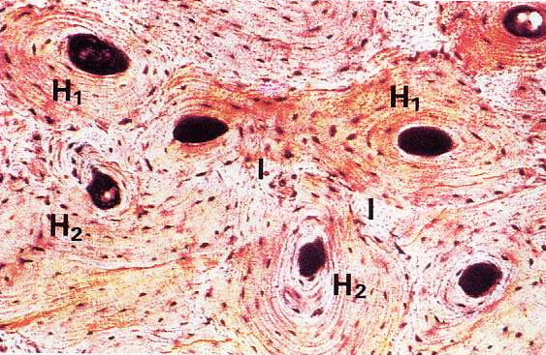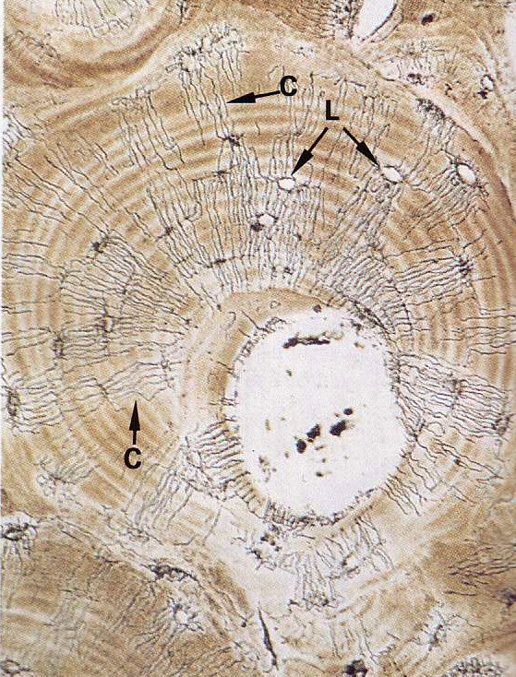

sections show some of the features we have just looked at.
Left
Transverse section showing newly formed haversian systems H1 and older partly resorbed ones H2.
I= irregular interstitial systems – i.e the remnants of resorbed haversian systems.

Right
Single haversian system
Central canal surrounded by concentric lamellae of bone matrix containing empty lacunae (L). where osteocytes normally sit
Fine canaliculi radiate for diffusion of fluid and metabolites.(C).

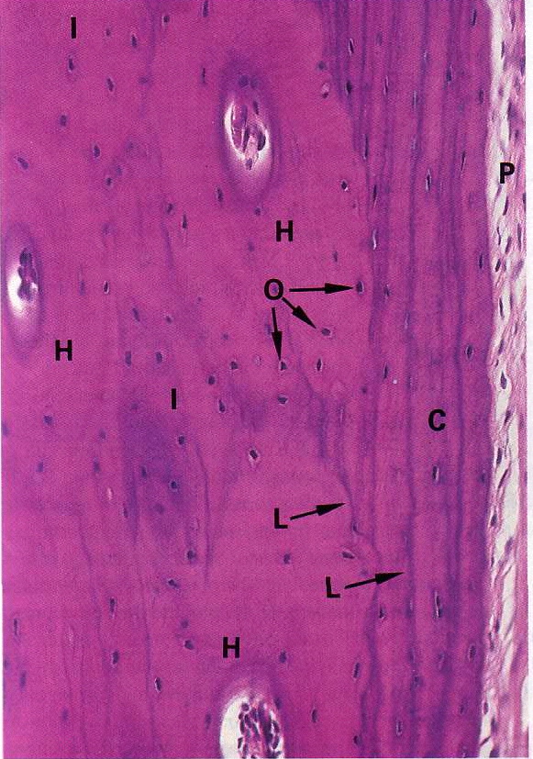

this is a decalcified section of bone – decalcify to make it easier to section.

H = several haversian systems, I= irregular interstitial systems.
The matrix of decalcified mature bone is very eosinophilic due to the high collagen content.

C is where the haversian system changes into cortical bone which as we know is a more dense protective outer system.

L= cement lines where the two join
P = fibrous periosteum.
O= osteocytes

Periosteum
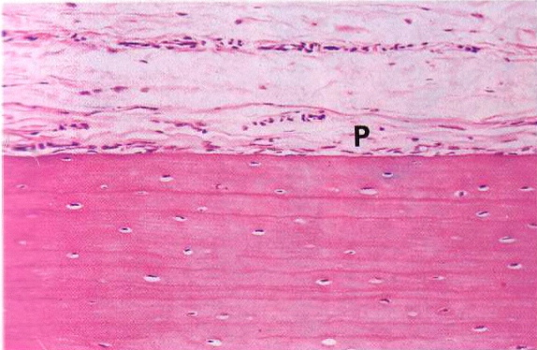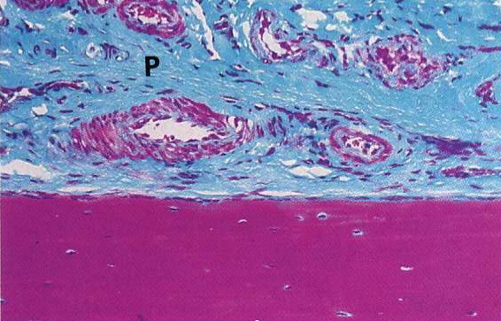
already seen that the outer layer of mature bone is covered with condensed fibrous tissue – the periosteum. Contains numerous osteoprogenitor cells. During bone growth or repair these cells differentiate into Osteoblasts
bundles of collagen fibres bind the periosteum to the underlying bone known as sharpeys fibres.
The collagen is stained blue green in the second micrograph.
Also see a rich blood supply
No periosteum is found at the articular surface or at ligament/tendon insertions.

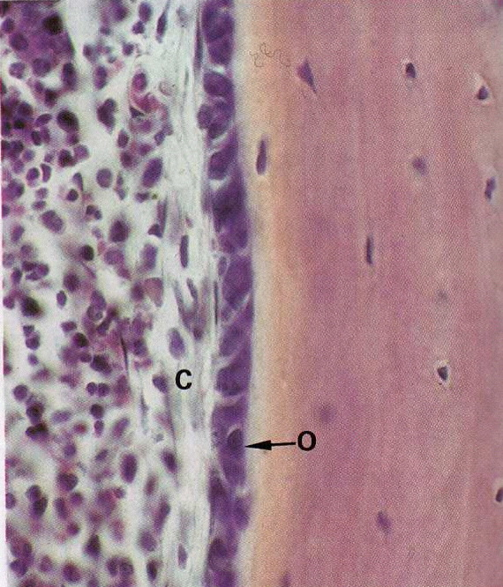
this is highly active periosteum from a developing fetal longbone.

Can see plump basophilic osteoblasts 2 or 3 cells deep, O. very basophilic due to lots of ER involved in synthesising collagen etc.

C= thin layer of collagenous tissue

Cancellous/spongy bone
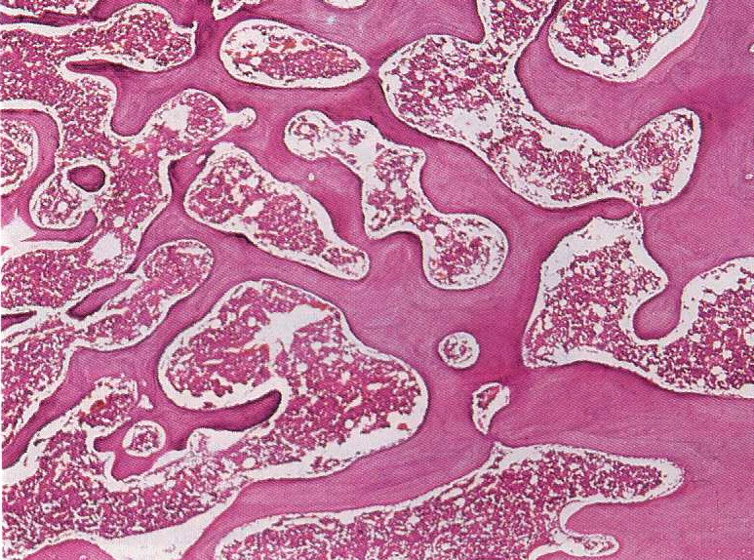
cancellous bone. Network of trabeculae separated by interconnecting spaces containing bone marrow
cancellous bone does not normally contain haversian systems and therefore the osteocytes exchange metabolites via canaliculi with blood sinusoids in the marrow.
The trabeculae are covered with endosteum which contain osteoprogenitor cells, osteoblasts and osteoclasts.

Cells
• Osteoblasts

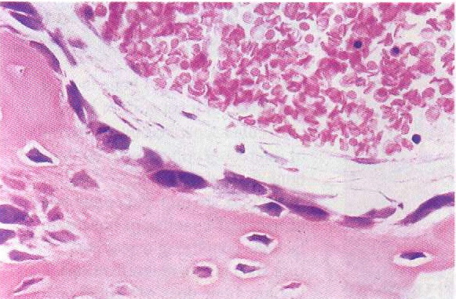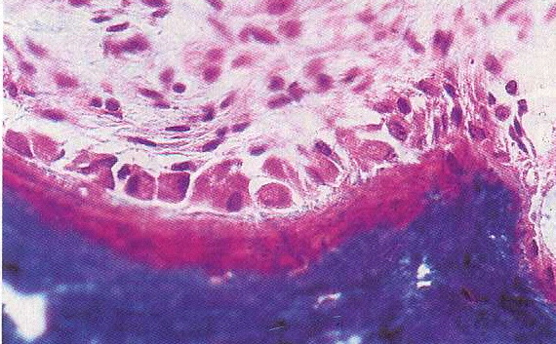
active osteoblasts in the process of laying down the organic components of bone matrix
known as osteoid..
already said that osteoblasts are large cells with basophilic cytoplasm, lots of ER and golgi
for protein and proteoglycan synthesis.
Left is normally developing bone where the osteoid becomes calcified soon after deposition.
Where adequate calcium and phosphate ions are not available (rickets, chronic renal
failure) there is a lag in the mineralization phase. Osteoid therefore accumulates. – b from a
man with chronic renal failure – red stained zone between the active osteoblasts and the
mineralised bone (blue).

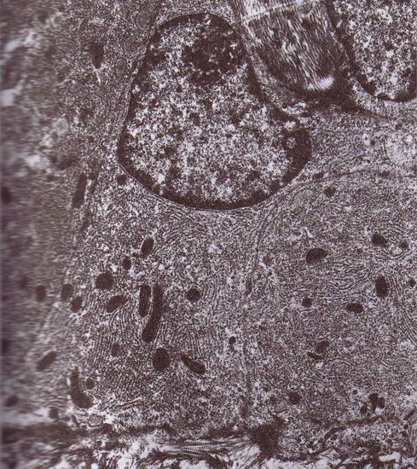

TEM of series of osteoblasts on a bone forming surface.

Cytoplasm filled with granular ER, some banded collagen fibres are visible at the secretory front at the base of the picture.

• Osteoclasts

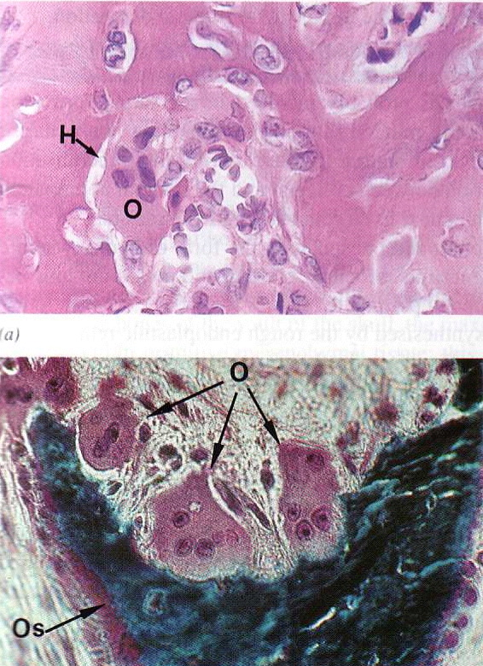
osteoclasts. Resorption of bone is
performed by these large multinucleate
cells – O.
these are often seen in depressions of
resorbed bone known as howships
lacunae -H. a ruffled border is present on
the resorption pit side of the cell.
The ruffled border secretes organic acids
which dissolve the mineral component of
bone while lysosomal proteolytic enzymes
destroy the organic matrix.

Osteoclasts also participate in blood calcium homeostasis by their response to parathyroid hormone and calcitonin. Pth stimulates osteoclastic resorption and the release of Ca ions from bone. Whereas calcitonin inhibits osteoclastic activity.
2nd micrograph is from a woman with low serum Ca level. This stimulates release of pth which promotes osteoclastic absorbtion. Os is where new bone formation mineralised is reduced.

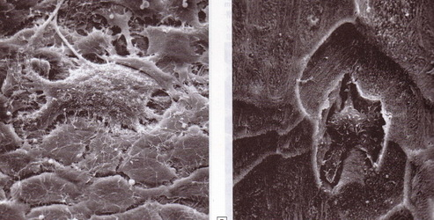
image 68um width

osteoclast lying amongst osteoblasts on the endocranial surface of a rat clavarium.

The osteoblasts form a continuous layer one cell thick over the bone, (crevices are artefacts of sem processing) filopdia contact adjacent cells.

• Osteocytes

34um width

endosteal surface of rabbit tibia showing an osteocyte within the lacunae exposed by osteoclastic resorption of surrounding bone.
Maintain structural integrity of mineralised matrix and control Ca release and deposition.

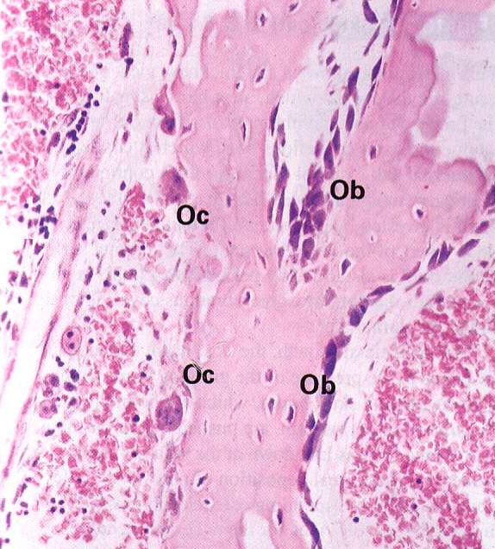
bone remodeling and repair.
Ob is bone formation and Oc is bone resorption.

This is actually known as woven bone which is the first type of bone to be laid down during development and repair of a fracture.

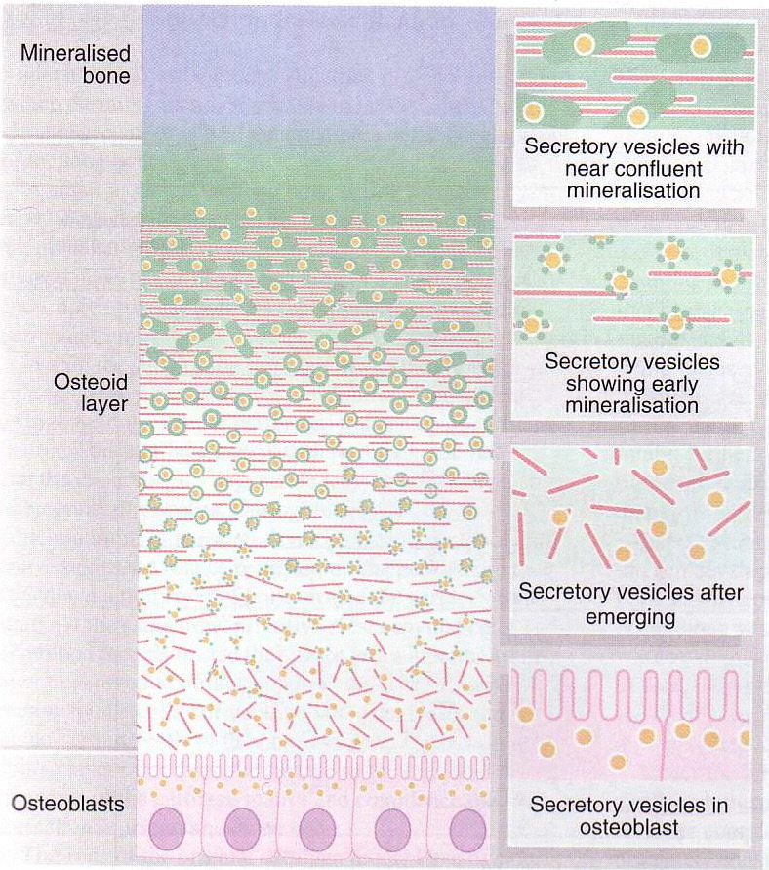
- Active cuboidal osteoblasts secrete osteoid collagen (red) and matrix vesicles (yellow), these are the focus for deposition of hydroxyapatite crystals (green) which is the first step in mineralization. Eventually get confluent mineralization of the collagen and supporting GAG matrix.
- Matrix vesicles are rich in alkaline phosphatase enzyme and pyrophosphatase which can both produce phosphate ions. These ions accumulate in the matrix vesicles along with Ca, and form the raw material for the production of hydroxyapatite.
- Mature compact bone contains 70% inorganic salts and 30% organic matrix.
- Collagen makes up over 90 % of the organic matrix the remainder being Proteoglycans and non-collagenous proteins which are involved in regulation of mineralization.
- Bone collagen makes up 50% of the total body collagen and is type 1 only. Spaces between the three-d structure of collagen are known as hole zones where mineral deposition occurs.
- The proteoglycans are less than in cartilage and are mainly chondroitin sulphate and hyaluronic acid.
- Non-collagenous proteins are osteocalcin (binds Ca during mineralistaion), osteonectin and sialoproteins

Key molecules for culture of osteoblasts
• Ascorbic acid required for collagen synthesis
• Dexamethasone
• Beta-glycerophosphate
both these are known as mineralization agents and are required as medium supplements in the in vitro culture of osteoblasts otherwise they will not mineralize.

Key genes
• Alkaline phosphatase
• Osteocalcin
• CBfa

