_________________________________________________________________________________

Tissue Engineering Bone Tissue Engineering Lecture 7 21/10/04
_________________________________________________________________________________

General and macroscopic features of bone structure
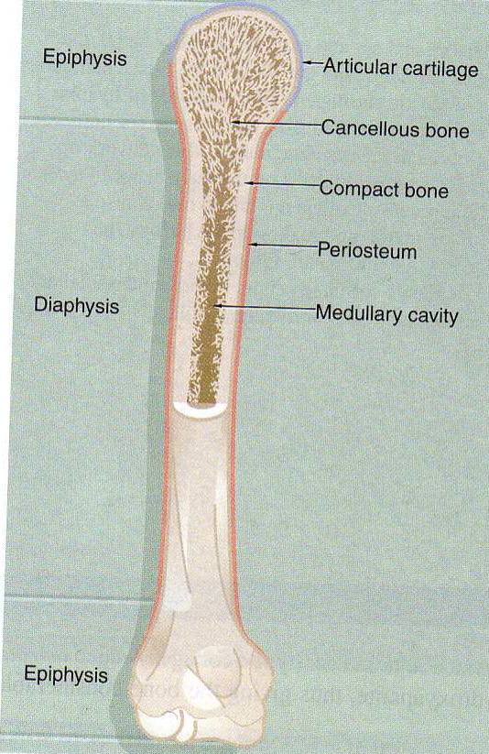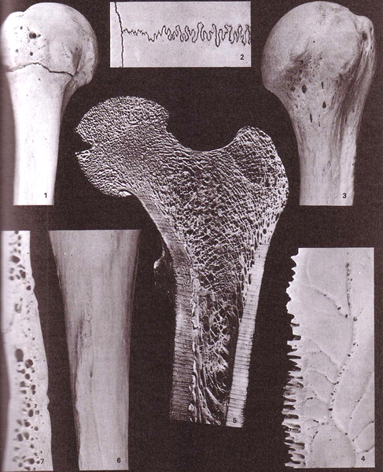

1. anterior aspect of the proximal end of an immature humerus
2. external aspect of part of the sagittal (horizontal) and coronal (vertical) cranial sutures.
3. anterior aspect of the proximal end of a mature humerus.
4. endocranial aspect of the sagittal margin of a parietal bone.
5. coronal section through the head neck and greater trochanter and proximal shaft of an adult femur 6. posterior aspect of part of the shaft of a tibia. 7. sectioned bone of the cranial vault.

Trabecular bone at different sites of a femur

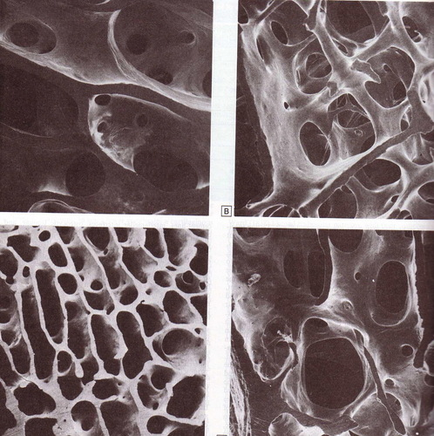

Main features of the blood supply of a long bone

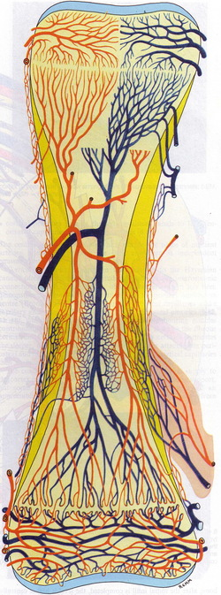

Compact bone
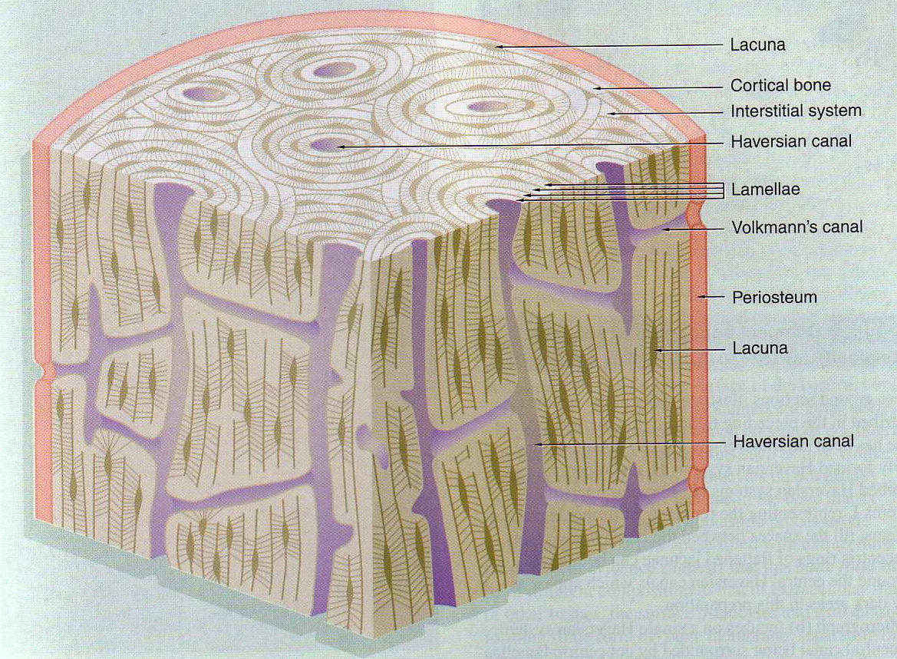

Transverse histological sections (compact bone)

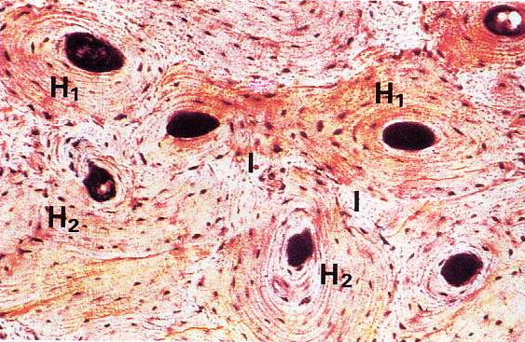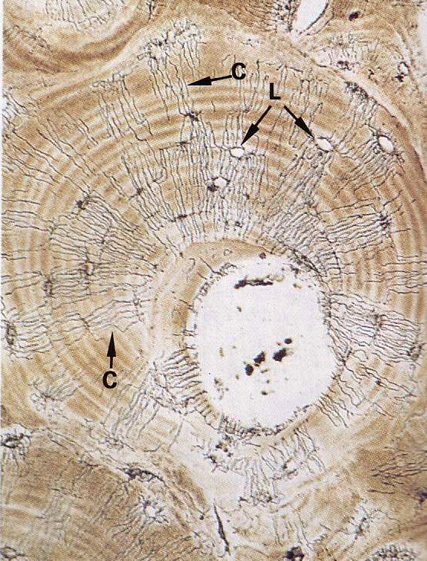

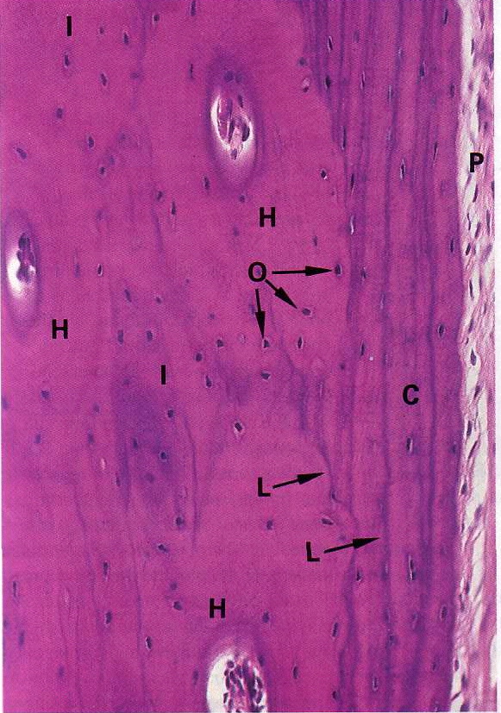

Periosteum
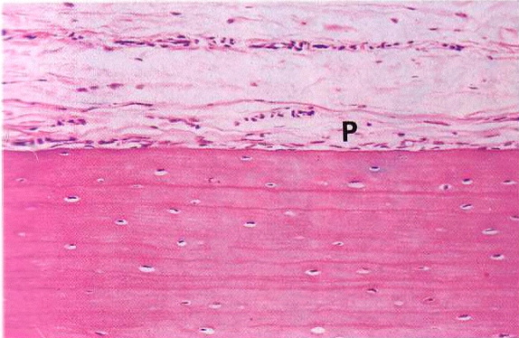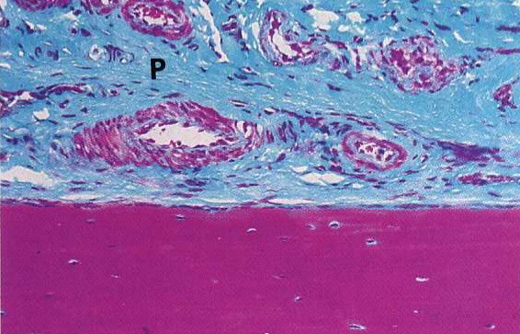

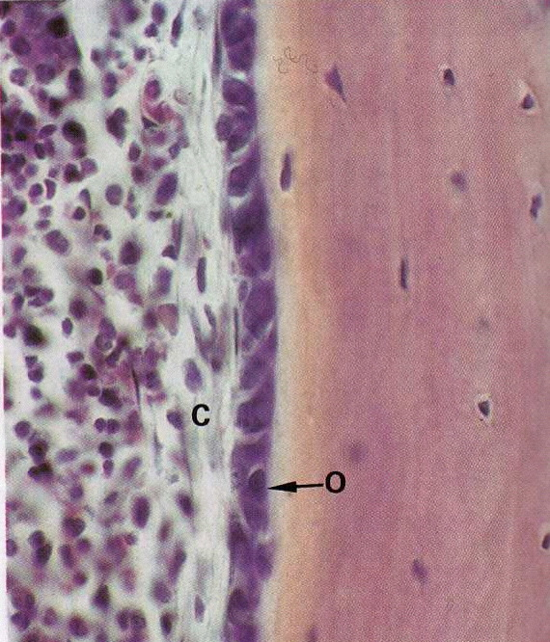

Cancellous/spongy bone

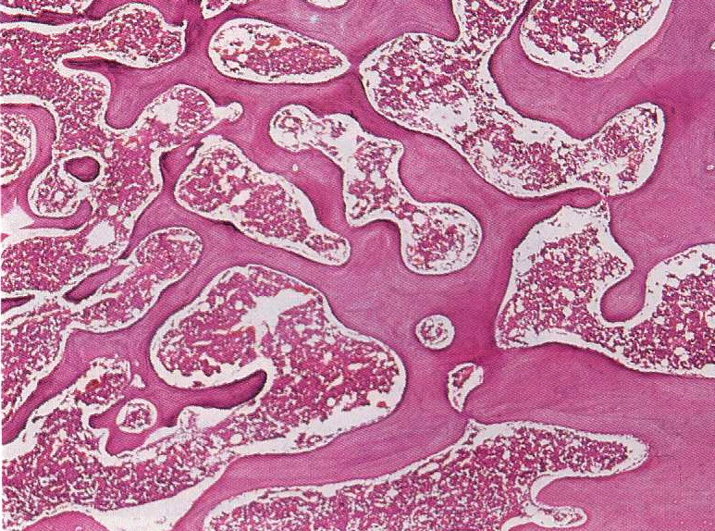

Cells
• Osteoblasts

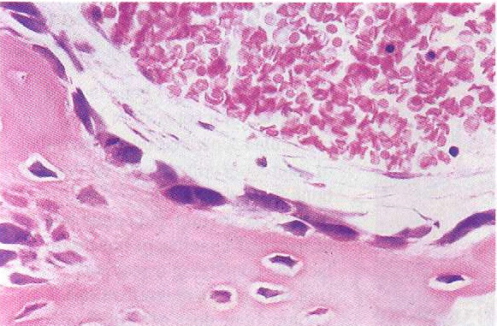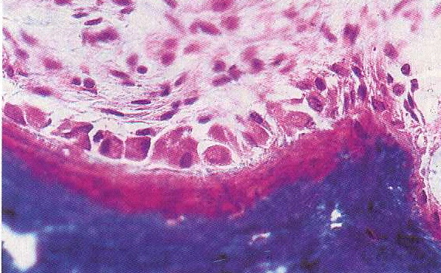

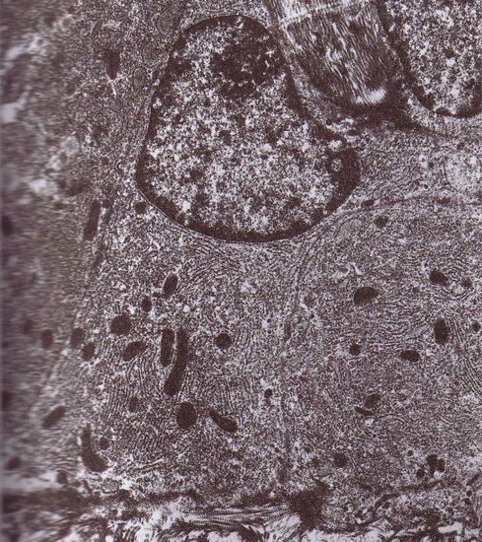

• Osteoclasts
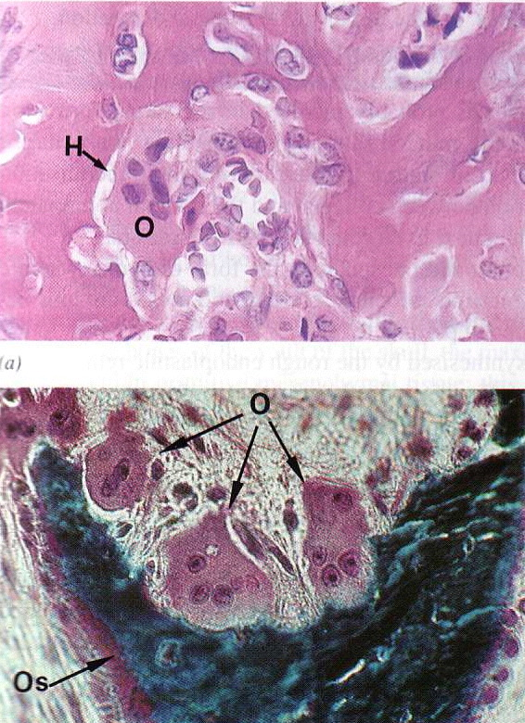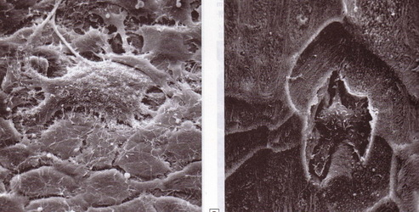

• Osteocytes

Bone remodelling

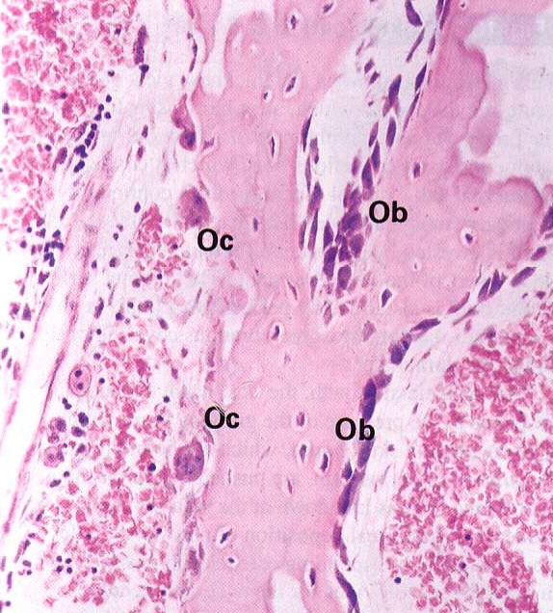

Mineralisation
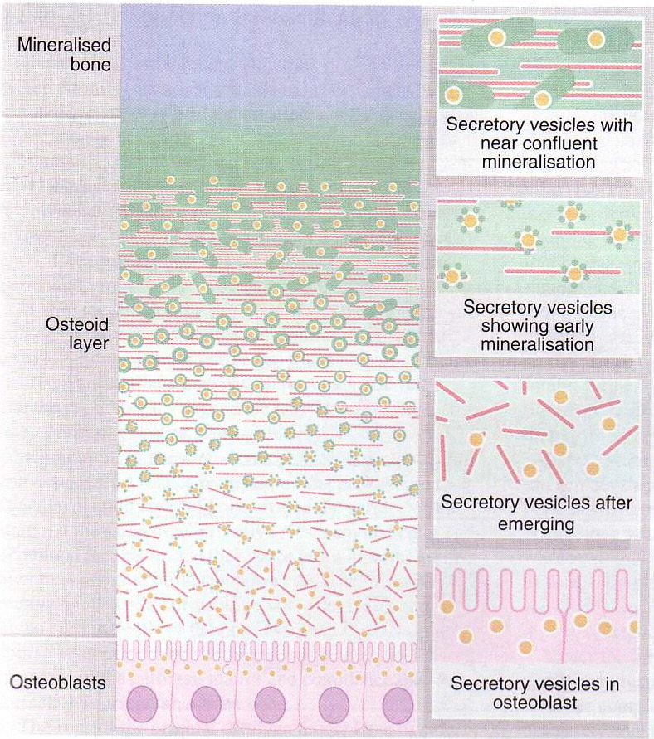

- Active osteoblasts secrete osteoid collagen (red) and matrix vesicles (yellow)
- Matrix vesicles contain alkaline phosphatase enzyme and pyrophosphatase - produce phosphate ions
- Mature compact bone contains 70% inorganic salts, 30% organic matrix
- Collagen is 90 % of the organic matrix the rest is proteoglycans and non-collagenous proteins
- Bone collagen is 50% of the total body collagen, type 1 only
- Less proteoglycans than in cartilage and are mainly chondroitin sulphate and hyaluronic acid.
- Non-collagenous proteins are osteocalcin (binds Ca during mineralistaion), osteonectin and sialoproteins

Key genes

- Alkaline phosphatase
  - Early stage marker essential for mineralisation
- Osteocalcin
  - Later marker, binds Ca and mineral
- Cbfa-1
  - Core binding factor α-1
  - Required for osteoblastic differentiation
  - Transcription factor
  - Regulates genes such as for osteocalcin
- Osterix
  - Required for osteoblastic differentiation
  - Acts downstream of Cbfa-1
  - Promotes expression of early markers such as BSP, osteonectin

Key molecules for culture of Osteoblasts

• Ascorbic acid
  - Required for collagen synthesis
• Dexamethasone
• Beta-glycerophosphate
Both are mineralization agents
• Bone morphogenetic proteins (BMPs)?
  - “osteogenic proteins” – induce bone formation
  - Approximately 20 BMPs identified
  - Involved in formation of cartilage as well as bone

