_________________________________________________________________________________

Module ML2921 Tissue Interactions and Biocompatibility

Lecture 5 Immune Response 3 11/10/04
_________________________________________________________________________________

Pathogens 2: Bacteria

The immune response to bacteria depends on:

- The type of bacteria i.e the bacterial cell wall
  - Gram positive
  - Gram negative
  - Mycobacteria
  - Spirochaetes

- The bacterial mechanism of pathogenicity
- Bacteria which invade
- Bacteria which produce toxin

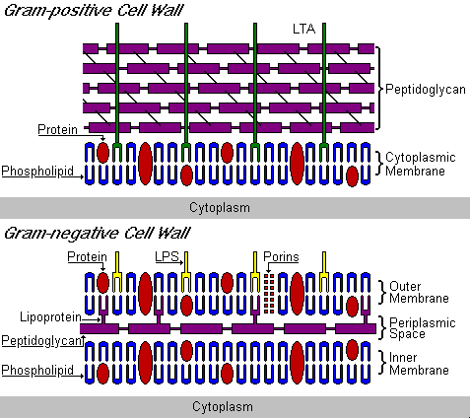

All bacteria have:
- Inner cell membrane
- Peptidoglycan cell wall

Gram -ve bacteria also have outer lipid bilayer with LPS
So therefore there are different mechanisms to attack different classes of bacteria
Lysozomal enzymes are active against peptidoglycan layer.
Cationic proteins and complement active against outer lipid bilayer of gram –ve bacteria
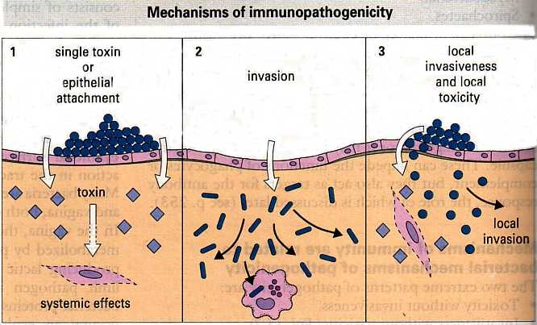
1. some case disease via toxin only e.g. diptheria and cholera bacteria OR by ability to colonise epithelial surfaces such as the sore throat bacteria (streptococcus).
Neutralizing Ab to toxin. Ab binding to bacteria to stop adhesion also important.
2. Invasion – tissues and sometimes cells, damage due to the bulk of the bacterial infection. Cell mediated immune response.
3. Most fall between the two. Ab and cell mediated responses.

Once sucessfully entered the host, the first line of attack is via the innate immune system

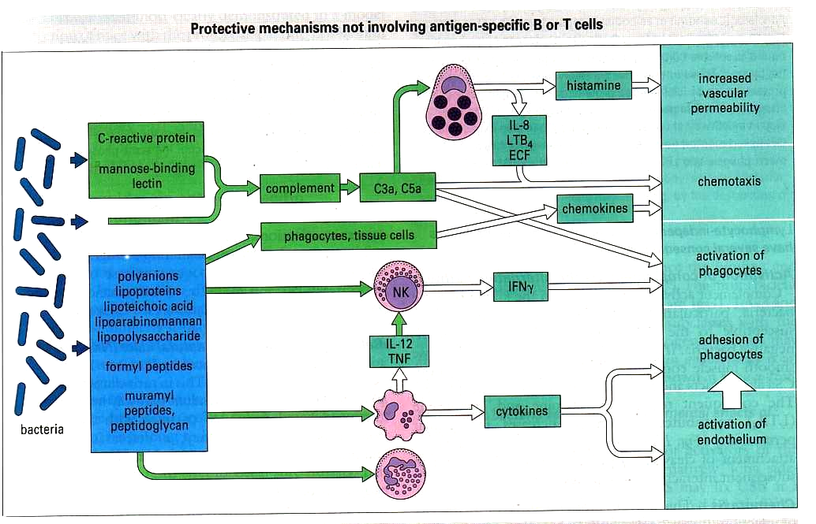
Numerous bacterial components are recognized in ways that do not rely on antigen specific receptors or B and T cells. There is an ancient broad spectrum of responses to common microbial components or “pathogen associated molecular patterns” - PAMPS. E.g LPS and mannan.

Mast cell, NK cell, mphage, nphil.
Lots common bacterial PAMPS are recognized by molecules in serum and by receptors on cells. This then results in activation of alternative complement pathway, activation of neutrophils, macrophages and NK cells triggering release of cytokines and chemokines, mast cell degranulation leads to increased blood flow in local capillary network. Increased adhesion of cells and fibrin to endothelial cells. These plus tissue injury activate the clotting system limiting bacterial spread.

These fairly non specific lymphocyte independent responses have several consequences:
Complement is activated by the alternative pathway
Activation can result in actual killing especially of bacteria with outer lipid bilayers which are susceptible to the lytic complex (C5b-9) – gram –ve bacteria
C3a and C5a are released which cause mast cell degranulation and this release of histamine increases vascular permeability.
C5a attracts and activates neutrophils
Opsonisation of bacteria occurs which is obviously important in later interactions of phagocytes.

Lymphocyte independent responses

Activation of complement (alternative pathway)

- Bacterial cell killing
- Release of C3a and C5a - mast cell degranulation
- C5a attracts and activates neutrophils
- Vascular permeability
- Opsonisation

Chemotaxis

Attracts more immune cells to the site of infection via complement or bacterial molecules and chemokines triggered by PAMPs.

Macrophage release of cytokines

- E.g. TNF and IL-1
- Activation of phagocytic cells
- Increased adhesion to endothelium
- Enter into inflamed tissue
- Increase motility of leucocytes

NK release of cytokines

E.g. IFN

Specific mechanisms: Antibody

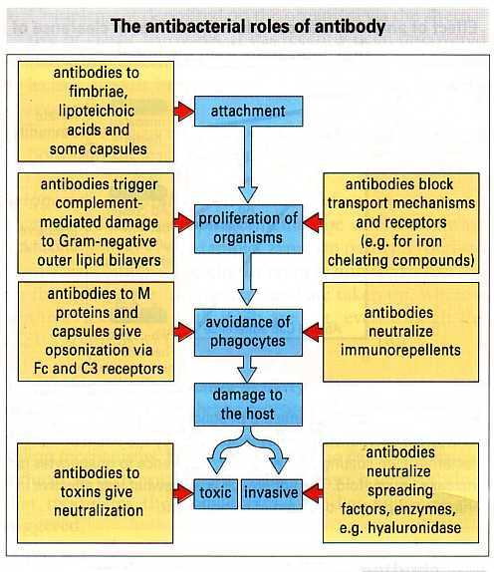
this diagram shows us mechanisms of bacterial establishment and Ab responses to some of these mechanisms.

Block attachment to host cell membranes, triggers complement mediated damage to bacterial lipid bilayers.
Blocks transport mechanisms
Opsonisation for phagocytosis
Immunorepellents i.e. bacterial factors that interfere with chemotaxis or phagocytosis are neutralized
Toxins and spreading factors such as enzymes that digest connective tissue are neutralized

The most important action is activation of complement as even organisms which resist the alternative pathway can be attacked:

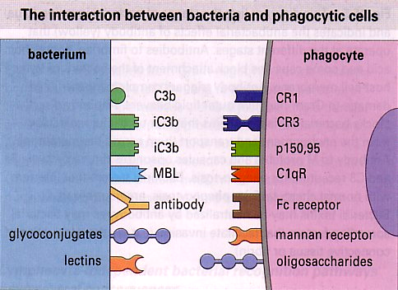
lots of molecules enable the binding of organisms to the phagocyte membrane MBL= mannose binding lectin.

Binding is crucial and is mediated by:
Lectins on the bacterial cell eg MBL
Lectins on the phagocyte e.g. complement receptors CR3 and LFA2 (leucocyte functional antigen) which have binding sites for carbohydrates
Complement deposited on the bacteria via both complement pathways
Fc receptors on the phagocyte which link to Ab on bacteria

Role of Antibody

ROLE IgG1 IgG2 IgG3 IgG4 IgM

Neutralize toxins + + + + +

Prevent binding to host cell + + + + +

Opsonize for PMNs + - + - -

Opsonize for macrophages + - + + +

Activate complement + + + - +

Phagocytic Killing:
Phagocytes have several methods:
Oxygen dependent

- Reduction of O₂ to superoxide anion •O₂⁻
- •O₂⁻ interacts with other molecules to give a series of free radicals
- Nitric oxide NO• is also produced which is toxic to bacteria and tumour cells

Oxygen independent

Organisms can be killed by patients who cannot produce reactive oxygen intermediates

Cationic proteins

Cysteine and arginine rich cationic peptides

Found in neutrophils

Form ion permeable channels in lipid bilayers

Other mechanisms

Acidification after lysosome fusion

Kills bacteria and also activates lysosomal enzymes

Extracellular Bacteria

- Gram negative
LPS outer membrane
Stimulates innate immune response
- Gram positive

Thicker and more resistant to IgG-complement lysis

- Ingested, killed by macrophages
- Antigens (peptides) presented by Class II MHC
- Class II-peptide stimulates CD4+ T cells
- Th1 cells activate macrophages
- Th2 cells stimulate B cells, activate eosinophils
- IgG and IgA important in response to extracellular bacteria
- Memory

Intracellular Bacteria

- Survive and replication inside phagocytic cells
- Sometimes within other host cells
- Evasion mechanisms
- Bacterial proteins become processed and presented
- T cell responses
- Th1 (CD4) secrete interleukins therefore activating the infected phagocytes
- Converted from habitat to an effector cell
- Cytotoxic T cells
- Lysis allows other phagocytes to act, increasing the response

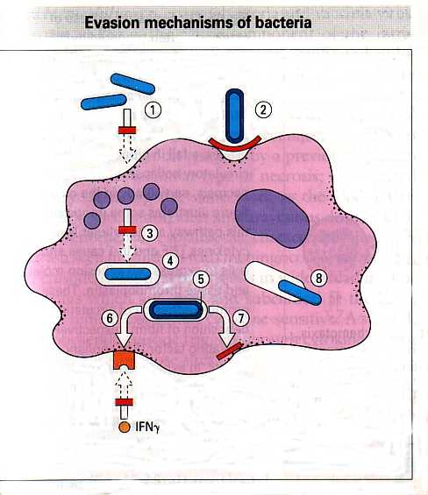

- Secrete repellents or toxins inhibiting chemotaxis
- Have capsules or outer coats which inhibit phagocyte attachment
- Allow uptake but release factors that block killing mechanisms
- Secrete catalase which inhibits hydrogen peroxide
- M.Leprae for example has highly resistant outer coat, phenolic glycolipid which scavenges free radicals
- Mycobacteria release lipoaribinomannan - blocks macrophages responding to IFN
- Stop antigen presentation
- Escape phagosome to multiply in cytoplasm

