_____________________________________________________________

Module ML2921 Tissue Interactions and Biocompatibility

Lecture 5 Immune Response 3 10/10/05

_____________________________________________________________

Pathogens 2: Bacteria

The immune response to bacteria depends on:

- The type of bacteria i.e the bacterial cell wall
  - Gram positive
  - Gram negative
  - Mycobacteria
  - Spirochaetes

- The bacterial mechanism of pathogenicity
- Bacteria which invade
- Bacteria which produce toxin

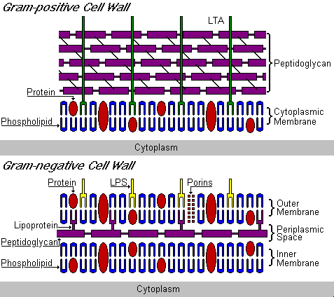

All bacteria have:
- Inner cell membrane
- Peptidoglycan cell wall

Gram -ve bacteria also have outer lipid bilayer with LPS

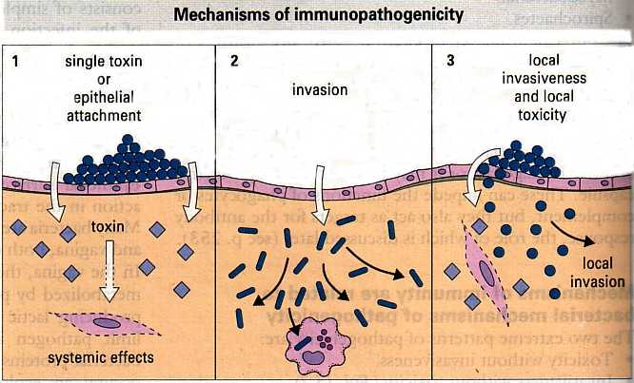

Once sucessfully entered the host, the first line of attack is via the innate immune system

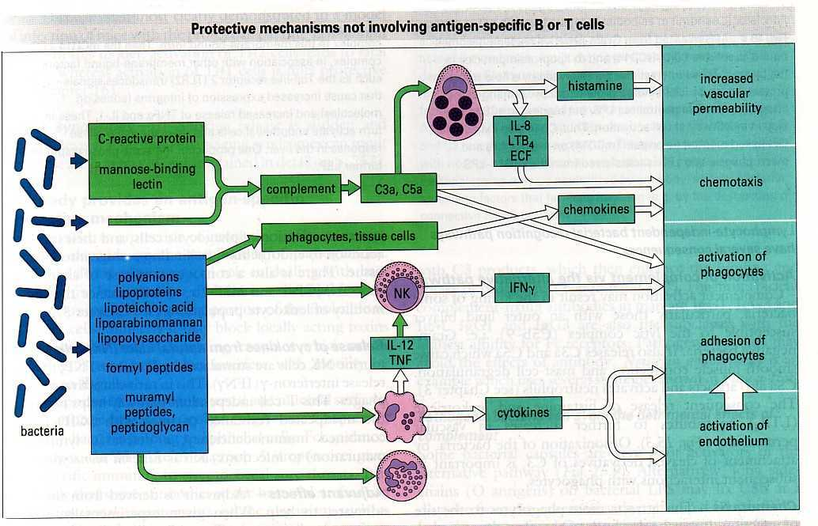

Lymphocyte independent responses

Activation of complement (alternative pathway)

- Bacterial cell killing
- Release of C3a and C5a - mast cell degranulation
- C5a attracts and activates neutrophils
- Vascular permeability
- Opsonisation

Chemotaxis

Attracts more immune cells to the site of infection via complement or bacterial molecules and chemokines triggered by PAMPs.

Macrophage release of cytokines

- E.g. TNF and IL-1
- Activation of phagocytic cells
- Increased adhesion to endothelium
- Enter into inflamed tissue
- Increase motility of leucocytes

NK release of cytokines

E.g. IFN

Specific mechanisms: Antibody

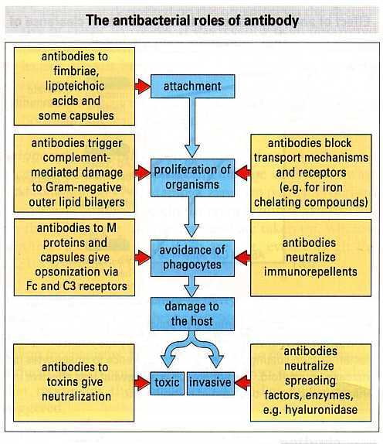

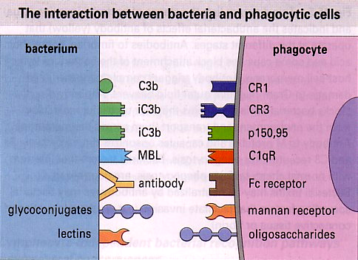

Role of Antibody

ROLE IgG1 IgG2 IgG3 IgG4 IgM

Neutralize toxins + + + + +

Prevent binding to host cell + + + + +

Opsonize for PMNs + - + - -

Opsonize for macrophages + - + + +

Activate complement + + + - +

Phagocytic Killing:

Oxygen dependent

- Reduction of O₂ to superoxide anion •O₂⁻
- •O₂⁻ interacts with other molecules to give a series of free radicals
- Nitric oxide NO• is also produced which is toxic to bacteria and tumour cells

Oxygen independent

Organisms can be killed by patients who cannot produce reactive oxygen intermediates

Cationic proteins

Cysteine and arginine rich cationic peptides

Found in neutrophils

Form ion permeable channels in lipid bilayers

Other mechanisms

Acidification after lysosome fusion

Kills bacteria and also activates lysosomal enzymes

Extracellular Bacteria

- Gram negative
LPS outer membrane
Stimulates innate immune response
- Gram positive

Thicker and more resistant to IgG-complement lysis

- Ingested, killed by macrophages
- Antigens (peptides) presented by Class II MHC
- Class II-peptide stimulates CD4+ T cells
- Th1 cells activate macrophages
- Th2 cells stimulate B cells, activate eosinophils
- IgG and IgA important in response to extracellular bacteria
- Memory

Intracellular Bacteria

- Survive and replication inside phagocytic cells
- Sometimes within other host cells
- Evasion mechanisms
- Bacterial proteins become processed and presented
- T cell responses
- Th1 (CD4) secrete interleukins therefore activating the infected phagocytes
- Converted from habitat to an effector cell
- Cytotoxic T cells
- Lysis allows other phagocytes to act, increasing the response

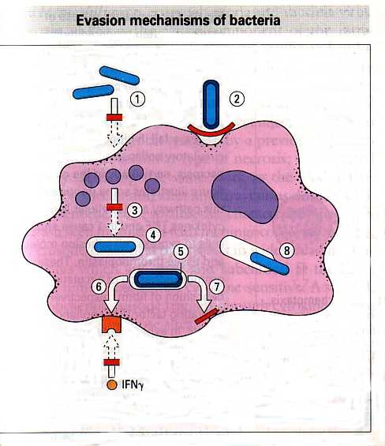

- Secrete repellents or toxins inhibiting chemotaxis
- Have capsules or outer coats which inhibit phagocyte attachment
- Allow uptake but release factors that block killing mechanisms
- Secrete catalase which inhibits hydrogen peroxide
- M.Leprae for example has highly resistant outer coat, phenolic glycolipid which scavenges free radicals
- Mycobacteria release lipoaribinomannan - blocks macrophages responding to IFN
- Stop antigen presentation
- Escape phagosome to multiply in cytoplasm

