_________________________________________________________________________________

Module ML2921 Tissue Interactions and Biocompatibility

Lecture 4 Pathogens 1: Viruses 05/10/05
_________________________________________________________________________________

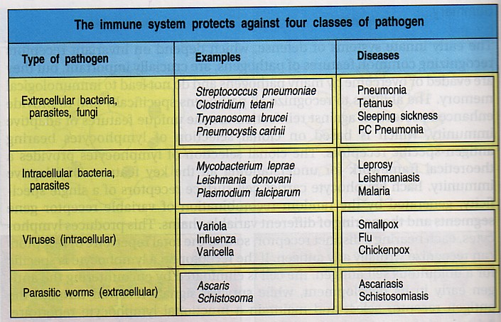

All pathogens must be able to:

- Colonize the host
- Find a nutritionally compatible niche
- Avoid, subvert or circumvent immune responses of the host<li>Replicate</li>
- Spread to a new host

Viruses are:
- Small non living particle
- Infects cells in organisms
- Obligate intracellular parasites
- Reproduce only by invading and controlling cells
- Lack machinery for self reproduction

Obligate intracellular parasites

Diverse in structure and complexity

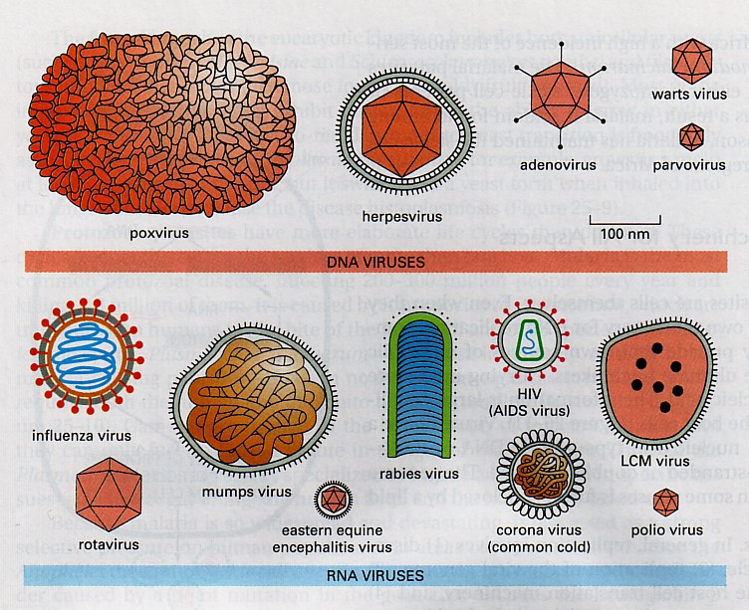

Composed of protein and nucleic acid

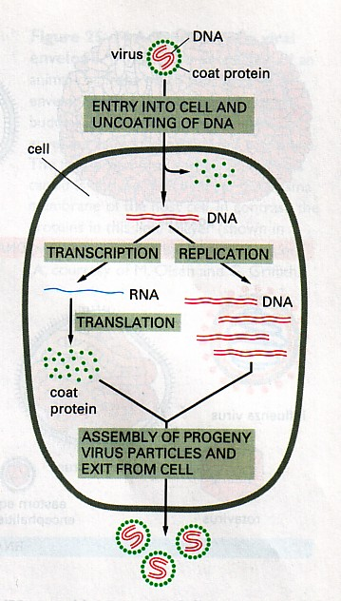

Image obtained for Molecular Biology of the Cell, Alberts et al, 4th edition, 2002.

Viruses bind to host cells via specific receptors

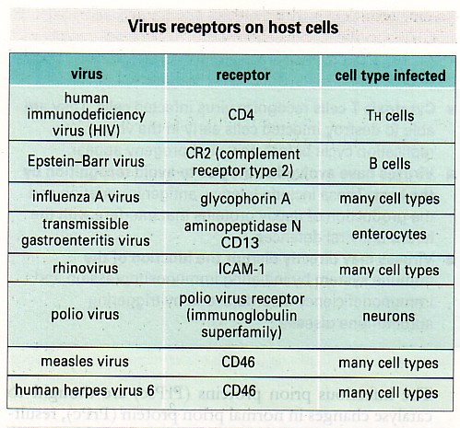

Viruses are diverse in their ability to infect

Commonly enter at mucosal surfaces
Punctured skin (insect bites, needles)

Replication often occurs at epithelial surfaces

Recovery involves elimination from the host, but some persist in a non-infectious form

Some can persist in an infectious form without immune response

Cells involved in the immune response against viruses:
- T helper cells
- Cytotoxic T cells
- LGLs/NK cells
- Macrophages

Soluble mediators involved:
- Interferons (IFNs)

Early non-specific or innate immune responses:
- Interferon
- NK cells
- Macrophages

Interferon

Three types:
- IFNα
- IFNβ

IFNγ

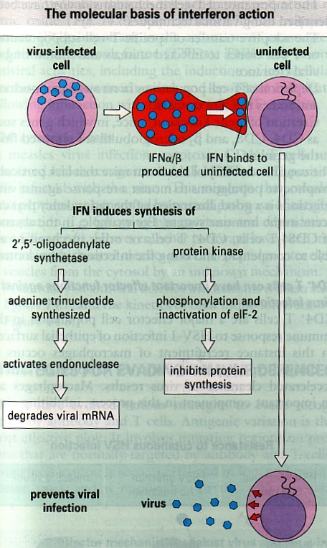

IFNs also:
- Increase expression of MHC class I and II molecules
- Activate macrophages and NK cells

NK Cells

NK cells are detected within 2 days of a viral infection

IFNγ activates NK cells

B and T Cells

After the early response and the infection proceeds, the adaptive immune response increases

- Cytotoxic T cells
- T helper cells
- Antiviral Abs

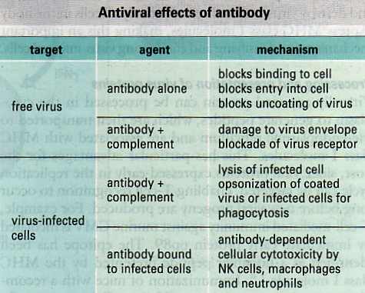

Antibodies and Complement

Complement can damage the virus envelope - virolysis

Some viruses directly activate both classical and alternative complement pathways

But complement is not a major antiviral factor

Antibody mediated activation of the complement system:

Destruction of virally infected cells

Assembly of membrane attack complex (complement components C5b,6,7,8,9)

T Cells

- Induce cytotoxic T cells

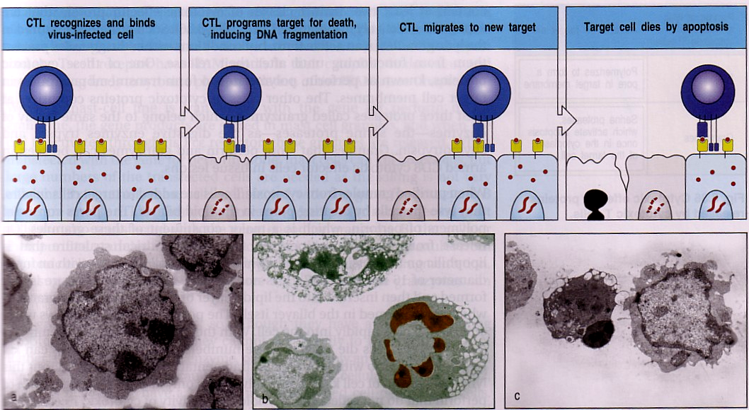

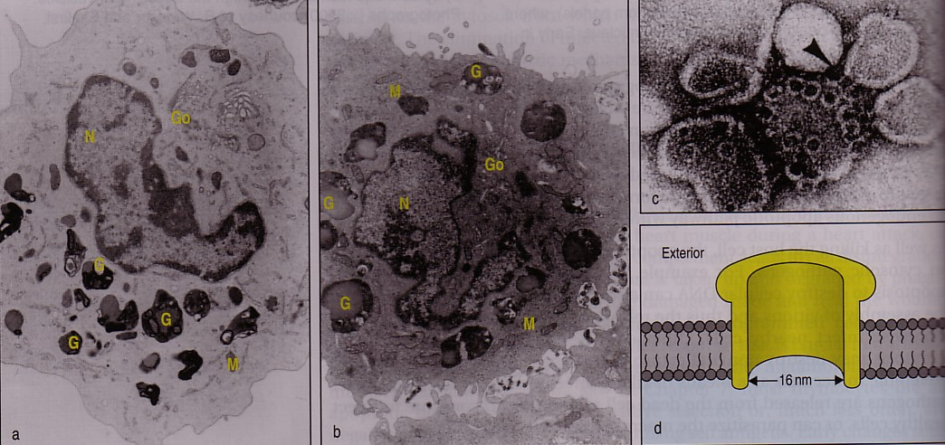

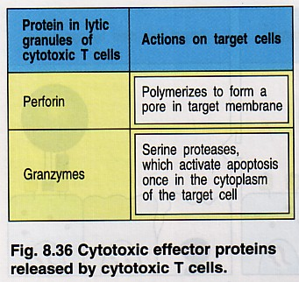

- Recruit and activate macrophages
- Help in prevention of reinfection

Processing and presentation of antigen
- Viral peptides are transported to the ER
- Associated with MHC class 1 molecules

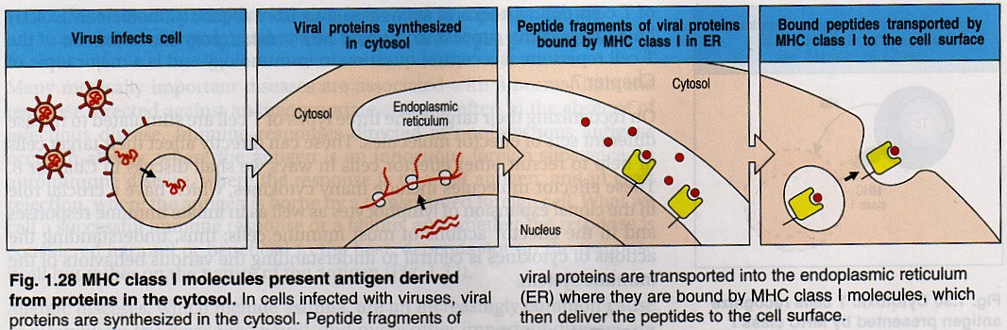

Macrophages generate nitric oxide

Activated by IFNγ

TNFα induces intracellular IFN defence mechanisms and apoptosis

In terms of the specific immune responses, the body defends itself against viruses 3 major ways:
- destroying the virus
- destroying the virus-infected host cell
- 3) protecting uninfected cells from becoming infected with viruses.

1.Destroying the virus

a): Opsonisation: IgG produced against viral epitopes, as well as C3b and C4b produced by the activated complement pathways, are able to attach the virus to phagocytes. They are then ingested and destroyed by lysosomes.
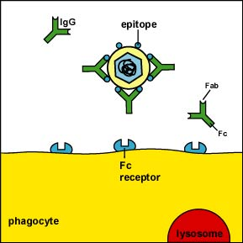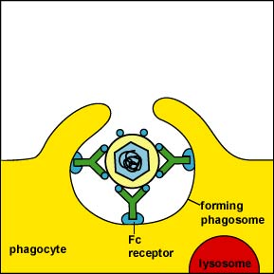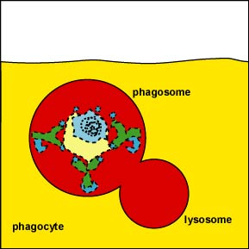

Membrane Attack Complex: MAC (membrane attack complex) from the activated complement pathways is able to damage the envelope of enveloped viruses causing their inactivation
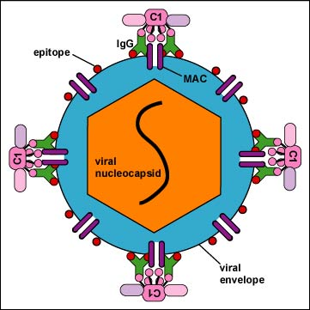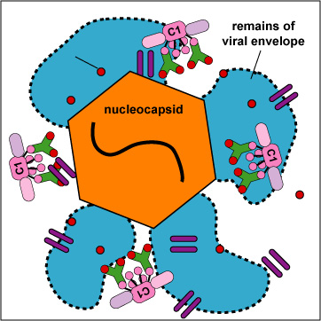

2.Destroying the virus-infected host cell:
1. Antibodies are made against viral epitopes on the host cell membrane. This results in:

a) Host cell opsonisation: IgG produced against the viral epitopes in the host cell membrane, as well as C3b and C4b produced by the activated complement pathways, are able to attach phagocytes to the infected cell. The phagocytes then discharge their lysosomes onto the infected cell causing its destruction.
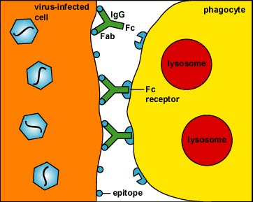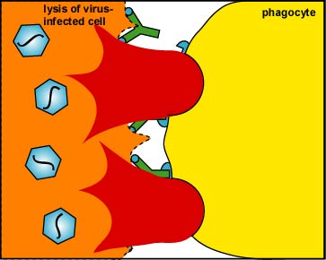

b) membrane attack complex: lysis of the virus-infected cell: The classical complement pathway is activated by IgG or IgM reacting with viral epitope on the host cell membrane and destroys the infected cell by MAC lysis.
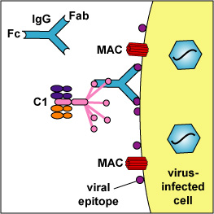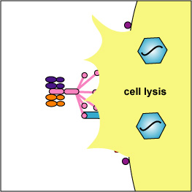

c) ADCC (AB dependent cell mediated cytotoxicity) The Fab portion of IgG binds to viral epitopes on virus-infected cells. NK cells then attach to the Fc portion of the antibody and destroy the infected cell by inserting pore-forming perforins and cytotoxic granzymes into the infected cell. This in turn triggers apoptosis of the infected cell.

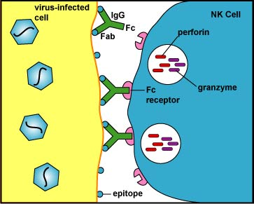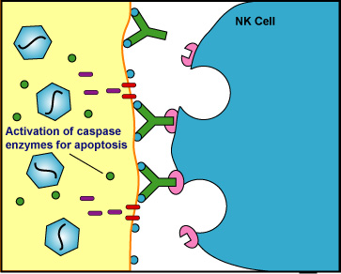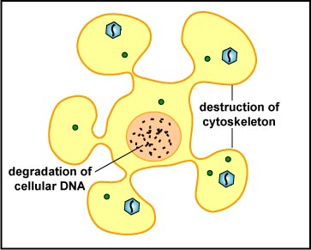

2. cytotoxic T cells: CTLs, by means of their TCR and CD8 bind to viral epitope/MHC-I on the infected cell's surface and destroy it by perforin and granzyme lysis or apoptosis. This is the most important and effective way of lysing infected cells.

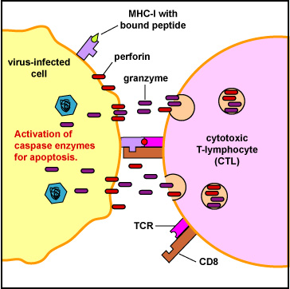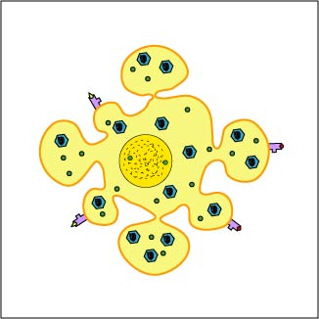

3. Natural Killer Cells: NK cells may directly lyse some virus-infected cells without prior sensitization to the virus by failing to recognize the cell as normal self. Viruses can sometimes interfere with the ability of the infected cell to express MHC-I molecules. Without the signal from the killer-inhibitory receptor, the kill signal from the killer-activating signal is not overridden and the NK cell kills the virus-infected cell to which it has bound. They destroy the cell by pore-forming perforins and cytotoxic granzymes. This in turn triggers apoptosis of the infected cell.

