_____________________________________________________________

Module ML2921 Tissue Interactions and Biocompatibility

Lecture 3 Immune Response 1 04/10/04

_____________________________________________________________

Introduction
Sometimes the implants develop complications, adverse interactions of the body with the device and vice versa.
Consequences that can include failure, harm or even death to the patient result from biomaterial-tissue interactions.
Effects on tissues on the implant and implant on the tissues are both important factors.
Most result from alterations of normal physiological processes for example immunity, inflammation and blood coagulation.
These are host defence mechanisms which protect us from dangerous external threats such as bacterial infections, injury and foreign materials.

We will first learn about the immune system, how the body fights infection, the wound healing response, inflammation and ultimately the immune response to biomaterials.

The environment in which we live constantly contains pathogens such as viruses and bacteria, yeasts parasites and fungi. These can cause disease and can be fatal if not treated. Most are short lived and cause little permanent damage. This is due to the many barriers which the body has and of course our immune systems.

The majority of these external threats we do not encounter due to the extremely effective biochemical and physical barriers as shown here:

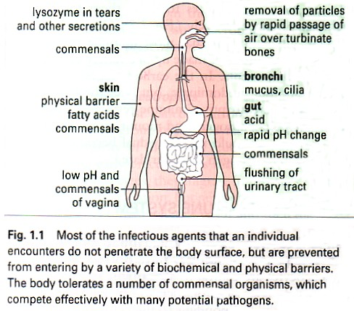

Image obtained from Immunology, sixth edition, Roitt, Brostoff, Male, 2001.
Many do however enter via epithelial membranes or via the blood stream

- Viruses
- Bacteria
- Fungi
- Protozoa
- Multicellular parasites
- Transplanted tissues
- Other foreign bodies such as biomaterials
The biggest distinction between these pathogens is between those that enter cells and those that do not
All viruses, some bacteria and some parasites replicate inside host cells. Many bacterial and larger parasites live in tissues between cells and in cavities.

Adaptive versus Innate Immunity

The immune system first recognizes a pathogen and then reacts to it

The immune response is divided into two stages:
- Innate immunity relatively non specific response to injury
- Adaptive immunity this is targetd and more focused to the specific causal agent. It improves in response on repeated exposure, it has memory and can prevent the agent from causing disease later. Two key features are therefore specificity and memory.

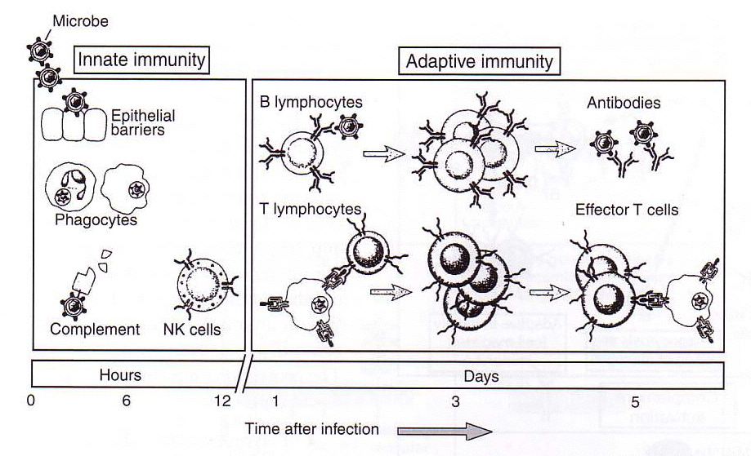
rapid response (hours) to infection is performed by components of the innate immune system.
Skin, epithelia, antimicrobial proteins, complement, phagocytes.
Evolutionary primitive system
First line of defence
Critical in mobilizing components of the adaptive response

The specific adaptive response is composed of cellular and circulating protein (humoral) mediators that are triggered specifically. - lymphocytes, antibodie, cytokines
Limitless diversity – can recognize 10¹¹ antigenic determinants

Components of the Immune System

The immune system is composed of:
- Cells
- Soluble mediators which the cells secrete
Leucocytes or wbc are central to the immune response but other cells are involved and participate by releasing signals to other cells and acting on signals received.

Main cells and molecules of the immune system:
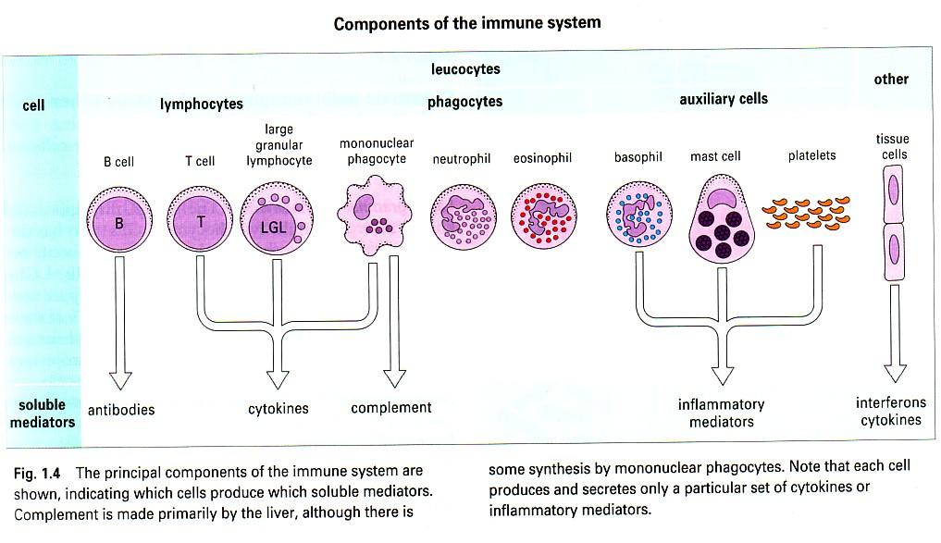
Image obtained from Immunology, sixth edition, Roitt, Brostoff, Male, 2001.

Cells of the Immune System

Phagocytes
- Monocytes / mononuclear phagocytes
From bone marrow stem cells, long lived, engulf, internalize and destroy. Migrate from the blood and become tissue macrophages.
Characteristic horse shoe shaped nucleus. And are larger than most circulating l’cytes
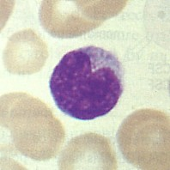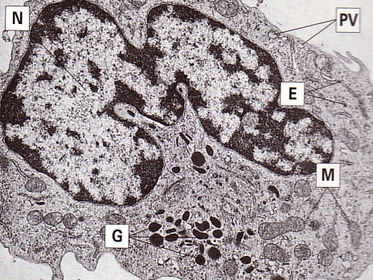
pinocytic vesicles, lysosomal granules, mitochondria and RER
- Macrophages
Biggest leucocyte, ultrastructure varies depending on state of activation, this EM shows macrophage engulfing particles. Irregular nucleus. Actively phagocytic cos has cytoplasmic projections – pseudopodia (P)
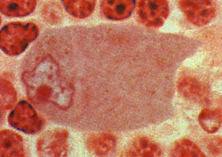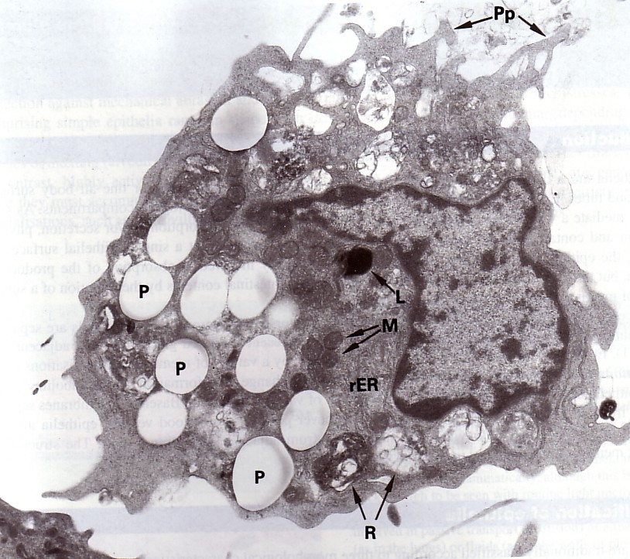

- Neutrophils / polymorphonuclear neutrophils /PMN

Migrate into tissues esp inflammatory sites. Short lived, engulf, destroy, die.
Multilobed nucleus
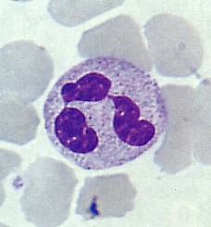
First line of defence against infection

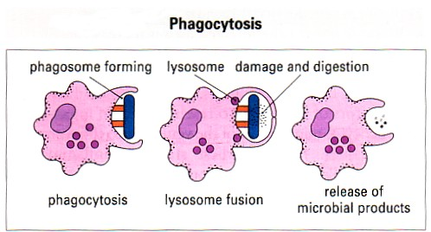
Image obtained from Immunology, sixth edition, Roitt, Brostoff, Male, 2001.
Phagocytes have several ways of dealing with engulfed pathogens. Can convert molecular oxygen into reactive oxygen intermediates and nitric oxide which are secreted into the phagosome and kill the pathogen

Lymphocytes

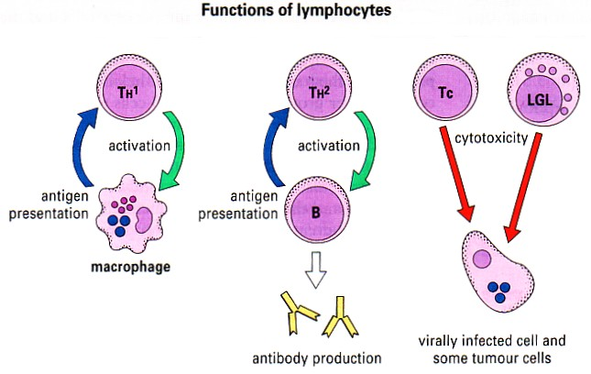
Image obtained from Immunology, sixth edition, Roitt, Brostoff, Male, 2001.
There are 2 types B cells and T cells., responsible for specific immune recognition
Derived from bone marrow stem cells but T cells mature in the thymus and B cells mature in the BM

B Cells
Produce antibody. Each B cell is genetically programmed to produce surface receptor specific to a particular antigen. Recognize Ag, multiply, differentiate into plasma cells and produce Ab which specifically binds to Ag that initially activated the B cells
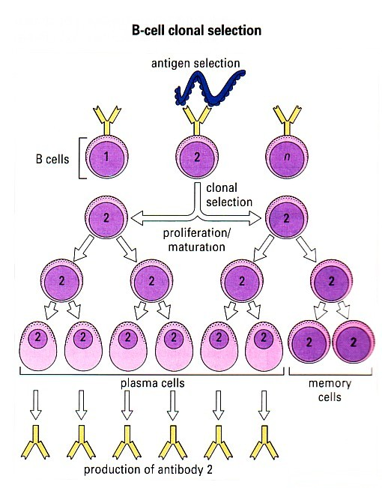

T Cells
Different types of T cell have different functions.
Type 1 T Helper cells – interact with monocytes/macrophages and help destroy intracellular pathogens.
Type 2 T Helper cells- interact with B cells and help them make Ab
Cytotoxic T cells – destroy host cells infected by viruses or other pathogens.

T Cell Antigen Recognition

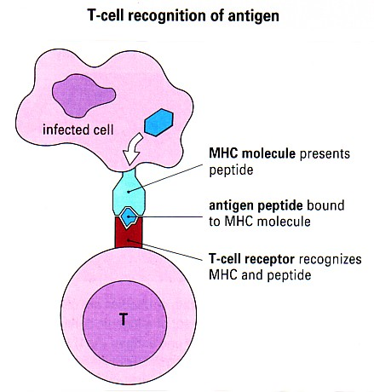
T cells recognize Ag when presented on the infected cell by its major histocompatibility complex using the T cell Ag receptor.

T cells then release cytokines (soluble proteins) which act as signals to other cells such as macrophages to come along and kill the infected cells.

Large Granular Lymphocytes (LGLs)/Natural Killer (NK) Cells

Are also a type of cytotoxic cell

Recognise surface changes on tumour cells and virally infected cells

Eosinophils

Bilobed nucleus and eosinophilic granules in cytoplasm (stain bright red with eosin dye) EM shows large ovoid granules which contain crystalloids and hydrolytic enzymes

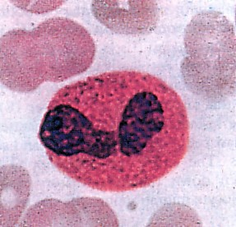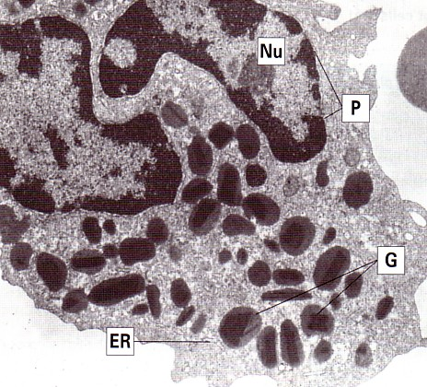

Engage and damage extracellular parasites e.g. schistosomes

Basophils and Mast Cells
These stain with basic or alkaline dyes to give deep violet blue granules.
Mast cells look similar to basophils.
EM bottom right is of a stimulated mast cell as exocytosis of granules has occurred
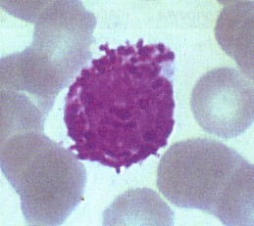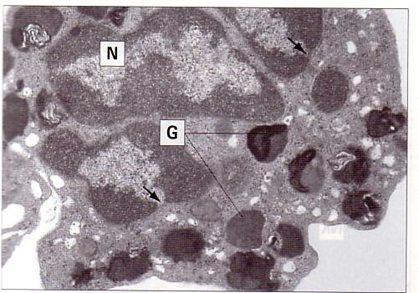

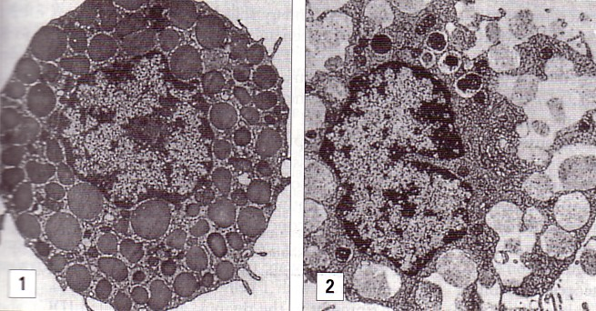

Release granules containing inflammatory mediators eg histamine

Basophils are mobile cells which circulate.
Platelets

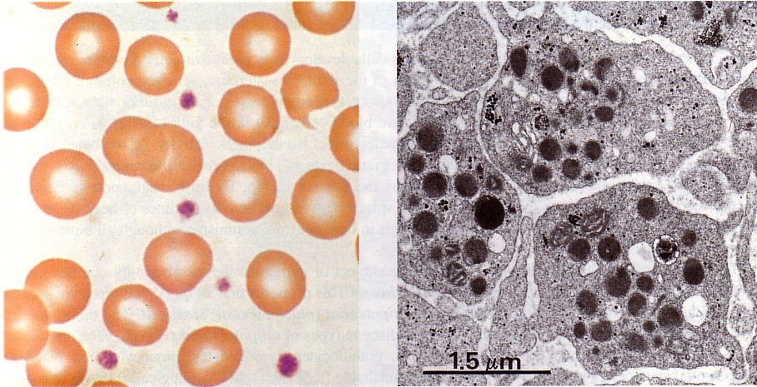

Also release inflammatory mediators when activated eg during thrombogenesis
or by means of Ag-Ab complex

Soluble Mediators

Antigens (Ag) and Antibodies (Ab)
There are a wide variey of molecules involved in the immune response e.g antibodies, cytokines, complement and make up the HUMORAL immune system

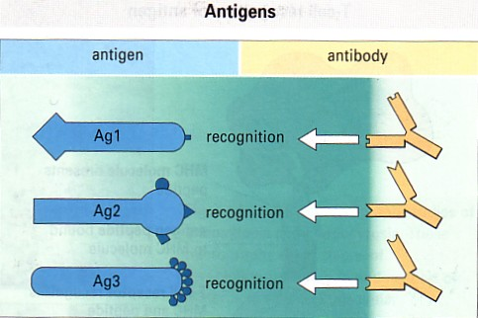

Ags possess specific antigenic determinants =epitopes

Either protein, lipid or carbohydrate

Lots of different Ags

Generate lots of different Ag specific Abs

Antibodies are immunoglobulins

There are 5 types:

- IgG
- IgM
- IgA
- IgD
- IgE

Have basic structure of 2 light chains and 2 heavy chains

These polypeptide chains are linked together by disulfide bonds

They differ in size, charge, aa composition and carbohydrate content.
Present in serum and tissue fluids of all mammals
Some are carried on the surface of B cells as Ag receptors
Some circulate

Functions of Immunoglobulins

TYPE | SERUM CONTENT | FUNCTION | STRUCTURE
IgG | 70-75% | Activates classical pathway of complement (elimination of pathogens, inflammation) | 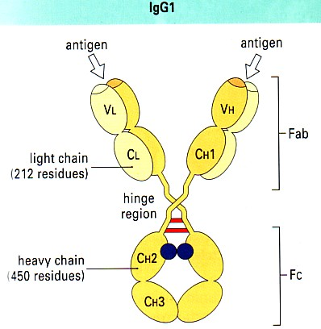
IgM | 10% | Blood borne infectious organisms. Activates c pathway of complement | 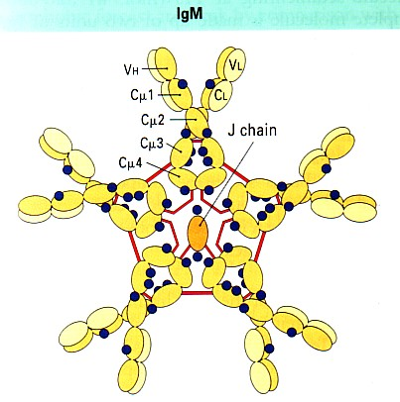
IgA | 15-20% | Protects mucosal surfaces | 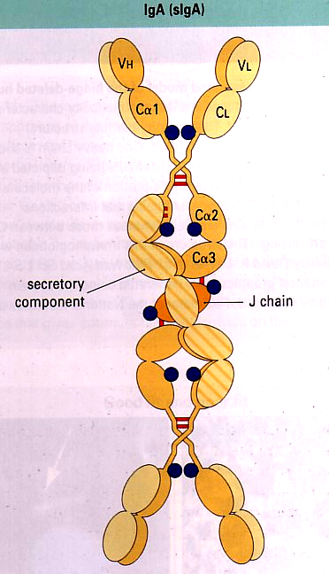
IgD | <1% | May have role in Ag triggered l'cyte functions | 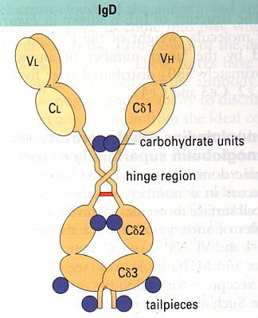
IgE | Very low | Parasites and allergies | 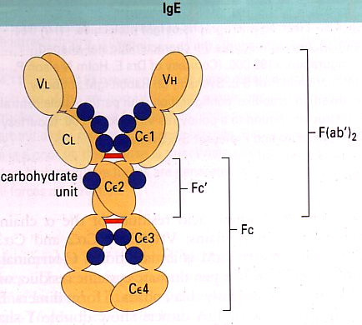

Complement

Group of approx. 30 serum proteins, main function is control of inflammation but also mediate phagocytosis and interact with antibodies – antibodies label, complement destroys

Complement activation is a cascade reaction
Inactive until becomes activated and cleaved by proteases

2 pathways: Classical where AB-AG binding is the trigger and Alternative

Activation by either pathway generates protein molecules which cause:

- Opsonization of microorganisms for phagocytosis
- Chemotaxis
- Increased blood flow and capillary permeability
- Damage to plasma membranes of cells which have activated complement
- Release of other inflammatory mediators from mast cells

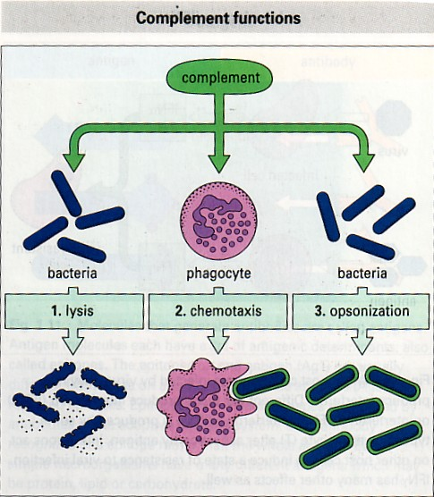

Cytokines

A large group of molecules which signal between cells during immune responses.

All are proteins, some are glycoproteins

There are the following groups of cytokines:

Interferons
Limit spread of viral infections
IFNα and IFNβ are produced by virally infected cells
IFNγ is released by activated T cells
Create antiviral resistance in uninfected cells

Interleukins
Direct other cells to divide and differentiate
IL-1 to IL-22
Produced by T cells, mononuclear phagocytes, tissue cells

Colony-stimulating factors
Direct division and differentiation of bone marrow stem cells
Direct further differentiation of cells outside the bone marrow e.g. M-CSF promotes development of monocytes and macrophages

Chemokines
Are chemotactic
Some activated specific functions of cells
Other cytokines
Tumour necrosis factor (TNFα and TNFβ), transforming growth factor-β (TGFβ)
Have many functions including inflammation and cytotoxic reactions

Each set of cells releases specific blends of cytokines dep on cell type and activation state.
There are of course occasions when the immune system goes wrong and these will be discussed later.
Examples are reaction to SELF antigens – autoimmunity such as MS.
Ineffective response – immunedeficiency, some are hereditary and some are acquired such as AIDS – acquired immunedeficiency syndrome
Overactive responses – hypersensitivity – out of proportion reaction to a pathogen or reaction to harmless agents such as food molecules.
Inconvenient but normal responses: blood transfusions and graft rejections.

Learnt a lot today but will become much clearer when we look at specific examples and the immune response to biomaterials.

