_____________________________________________________________

Module ML2921 Tissue Interactions and Biocompatibility

Lecture 3 Immune Response 1 03/10/05

_____________________________________________________________

Introduction

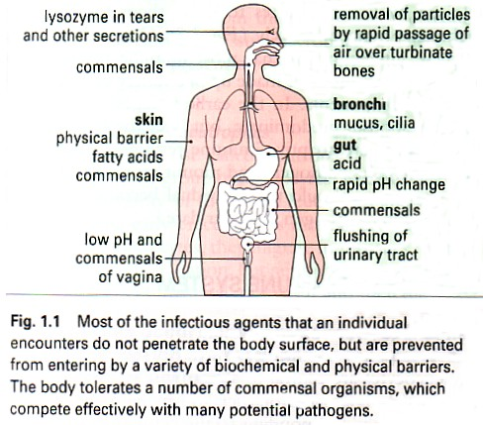

Image obtained from Immunology, sixth edition, Roitt, Brostoff, Male, 2001.

- Viruses
- Bacteria
- Fungi
- Protozoa
- Multicellular parasites
- Transplanted tissues
- Other foreign bodies such as biomaterials

Adaptive versus Innate Immunity

The immune system first recognizes a pathogen and then reacts to it

The immune response is divided into:
- Innate immunity
- Adaptive immunity
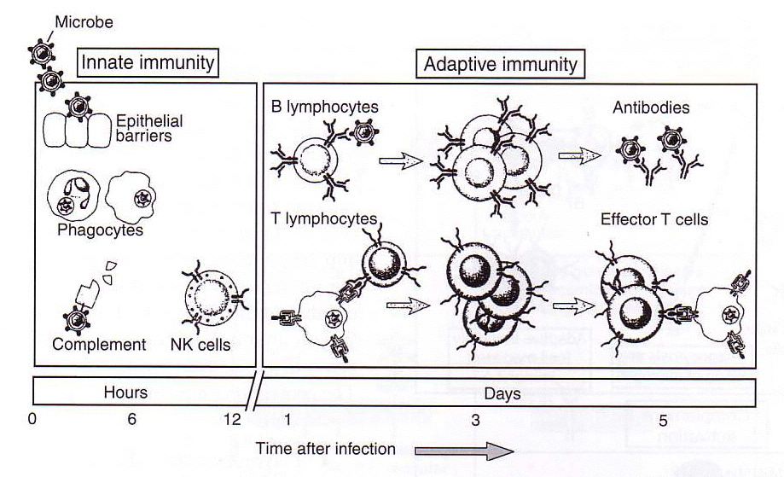

Components of the Immune System

The immune system is composed of:
- Cells
- Soluble mediators which the cells secrete

Main cells and molecules of the immune system:

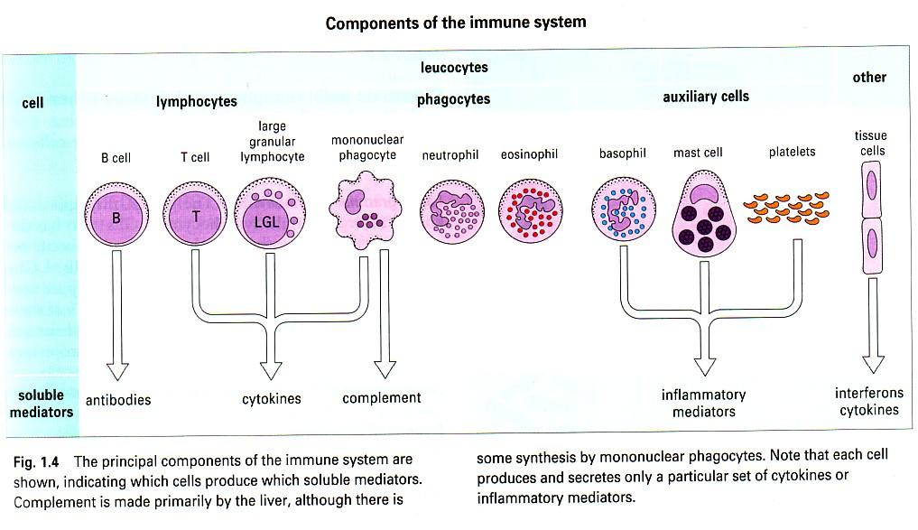
Image obtained from Immunology, sixth edition, Roitt, Brostoff, Male, 2001.
Phagocytes
- Monocytes / mononuclear phagocytes

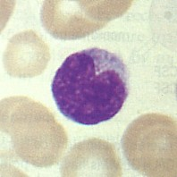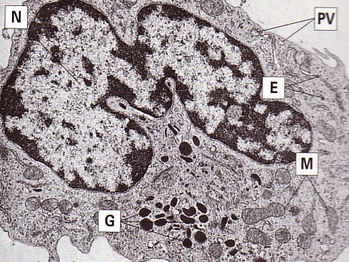

- Macrophages
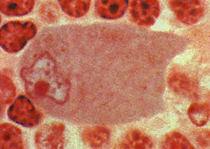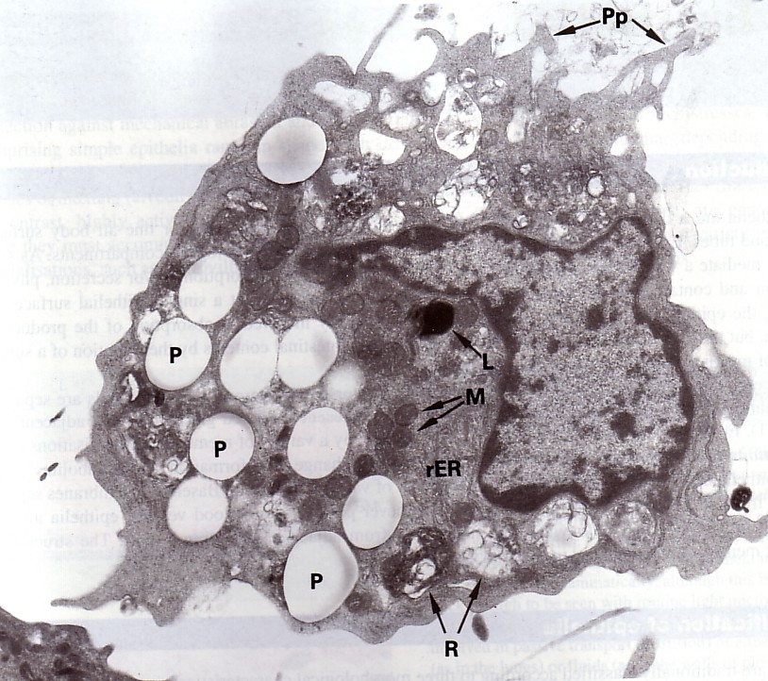

- Neutrophils / polymorphonuclear neutrophils /PMN

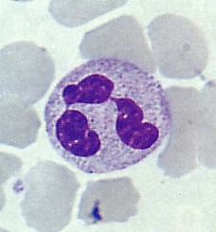

First line of defence against infection

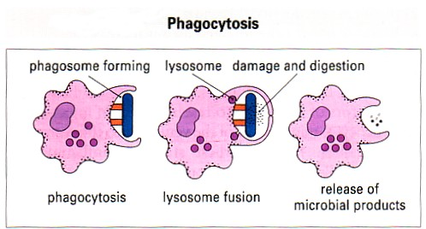
Image obtained from Immunology, sixth edition, Roitt, Brostoff, Male, 2001.

Lymphocytes

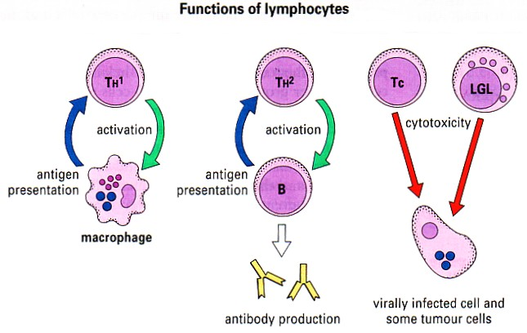

Image obtained from Immunology, sixth edition, Roitt, Brostoff, Male, 2001.

B Cells

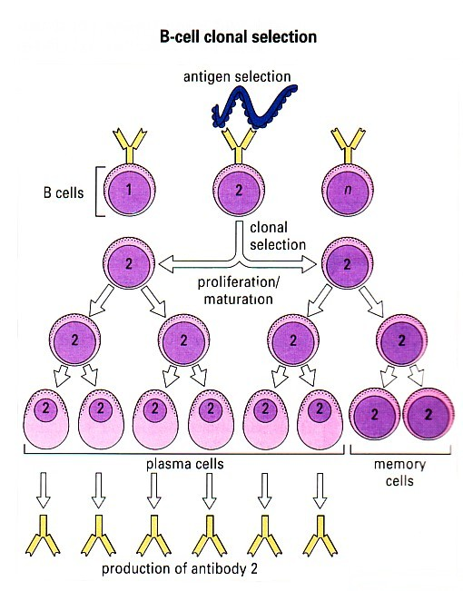

T Cells

T Cell Antigen Recognition

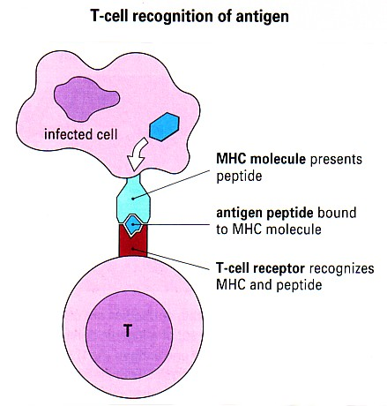

Large Granular Lymphocytes (LGLs)/Natural Killer (NK) Cells

Are also a type of cytotoxic cell

Recognise surface changes on tumour cells and virally infected cells

Eosinophils

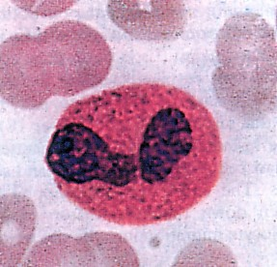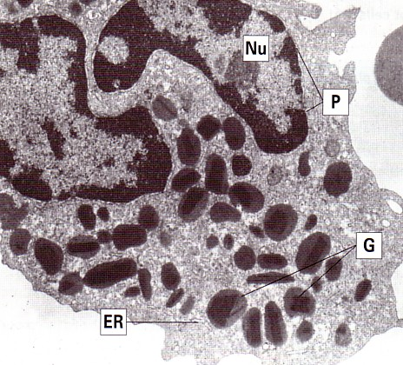

Engage and damage extracellular parasites e.g. schistosomes

Basophils and Mast Cells

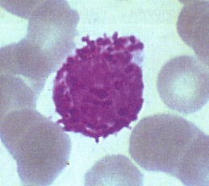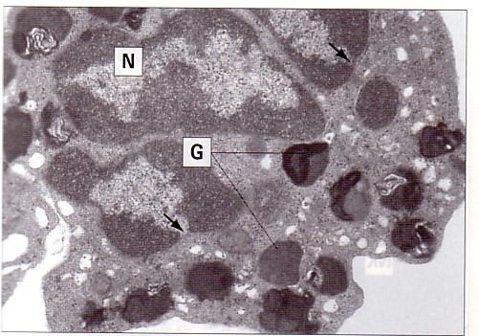

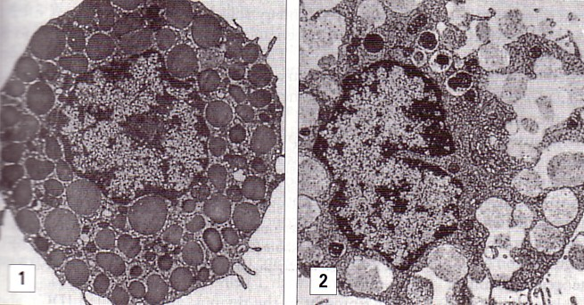

Release granules containing inflammatory mediators eg histamine

Basophils are mobile cells which circulate.

Platelets

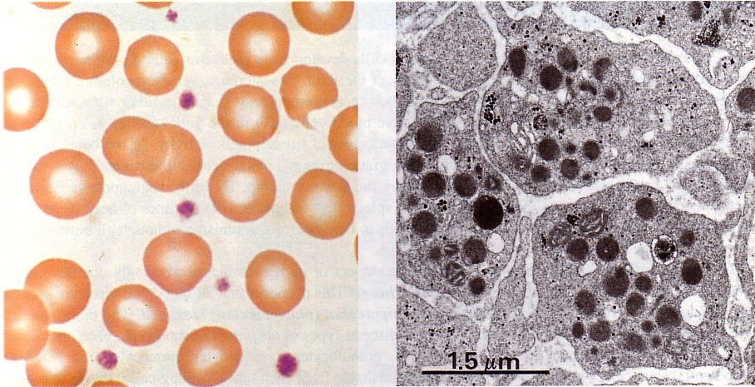

Also release inflammatory mediators when activated eg during thrombogenesis
or by means of Ag-Ab complex

Soluble Mediators

Antigens (Ag) and Antibodies (Ab)

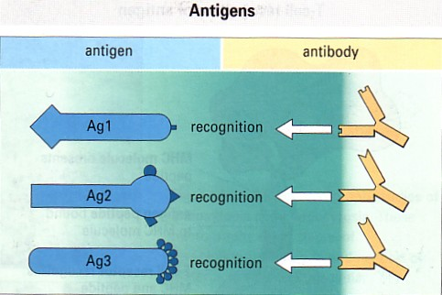

Ags possess specific antigenic determinants =epitopes

Either protein, lipid or carbohydrate

Lots of different Ags

Generate lots of different Ag specific Abs
Antibodies are immunoglobulins
There are 5 types:

- IgG
- IgM
- IgA
- IgD
- IgE

Have basic structure of 2 light chains and 2 heavy chains
These polypeptide chains are linked together by disulfide bonds

Functions of Immunoglobulins

TYPE | SERUM CONTENT | FUNCTION | STRUCTURE
IgG | 70-75% | Activates classical pathway of complement (elimination of pathogens, inflammation) | 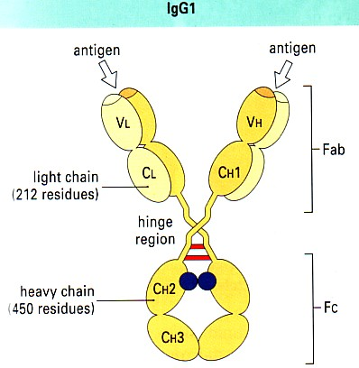
IgM | 10% | Blood borne infectious organisms. Activates c pathway of complement | 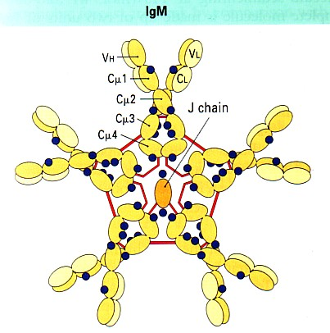
IgA | 15-20% | Protects mucosal surfaces | 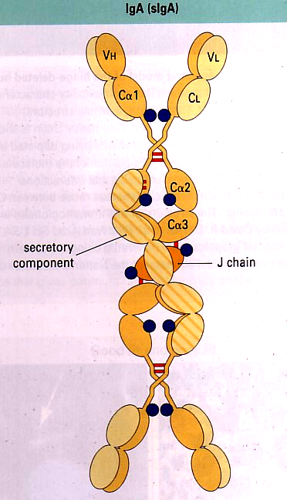
IgD | <1% | May have role in Ag triggered l'cyte functions | 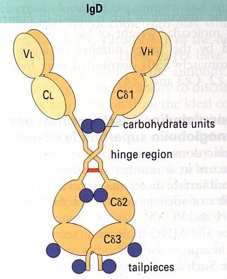
IgE | Very low | Parasites and allergies | 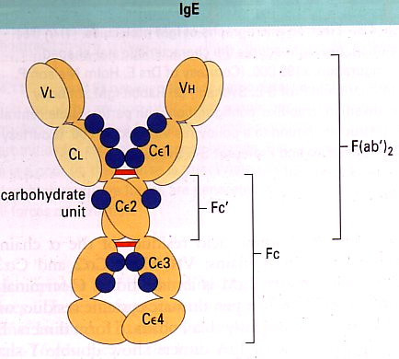

Complement

Group of approx. 30 serum proteins, main function is control of inflammation but also mediate phagocytosis and interact with antibodies

Complement activation is a cascade reaction

2 pathways: Classical and Alternative

Activation by either pathway generates protein molecules which cause:

- Opsonization of microorganisms for phagocytosis
- Chemotaxis
- Increased blood flow and capillary permeability
- Damage to plasma membranes of cells which have activated complement
- Release of other inflammatory mediators from mast cells

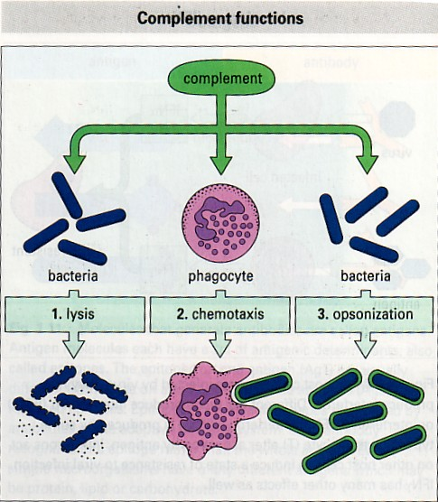

Cytokines

A large group of molecules which signal between cells during immune responses.

All are proteins, some are glycoproteins

There are the following groups of cytokines:

Interferons
Limit spread of viral infections
IFNα and IFNβ are produced by virally infected cells
IFNγ is released by activated T cells
Create antiviral resistance in uninfected cells

Interleukins
Direct other cells to divide and differentiate
IL-1 to IL-22
Produced by T cells, mononuclear phagocytes, tissue cells

Colony-stimulating factors
Direct division and differentiation of bone marrow stem cells
Direct further differentiation of cells outside the bone marrow e.g. M-CSF promotes development of monocytes and macrophages

Chemokines
Are chemotactic
Some activated specific functions of cells
Other cytokines
Tumour necrosis factor (TNFα and TNFβ), transforming growth factor-β (TGFβ)
Have many functions including inflammation and cytotoxic reactions

