Module ML2921 Tissue Interactions and Biocompatibility

Lecture 1 Protein Adsorption 27/09/04
_____________________________________________________________

What might the tissue interactions be?

What is biocompatibility?

What is the difference between these definitions:

“not having a toxic or injurious effect on biological systems”
“the ability of a material to perform with an appropriate host response in a specific application”
“a material intended to interface with biological systems to evaluate, treat, augment, or replace a tissue, organ or function of the body”

materials have moved from being inert to active

Protein adsorption:
The first event when a material is implanted or placed into cell culture

TIMESCALE EVENT
<1 second Proteins adsorb
Seconds-minutes Protein monolayer
Minutes Cells arrive

Cells respond to specific proteins

So therefore?
Different proteins adsorbed to a surface lead to different cell responses

What determines whether proteins adsorb?
Surface of the material - its chemistry and topography

What determines whether cells then attach?
Type and conformation
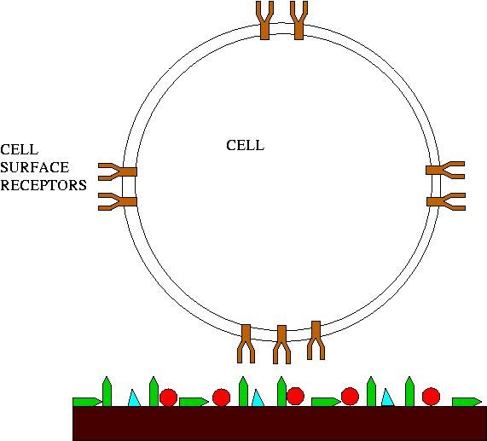

the adhesion of proteins to a surface makes the material biologically recognizable – cells are now able to attach to the material, including cells of the immune system.

What is next stage after cells adhere?
Spreading, proliferation, release of cytokines, growth factors, cell recruitment, tissue formation

Proteins can have complex structures
For example the fibronectin molecule:
This is a large glycoprotein found in connective tissue, cell surfaces, body fluids/blood plasma.
It interacts with membranes and the ECM
It has many domains, some of which are specific binding sites
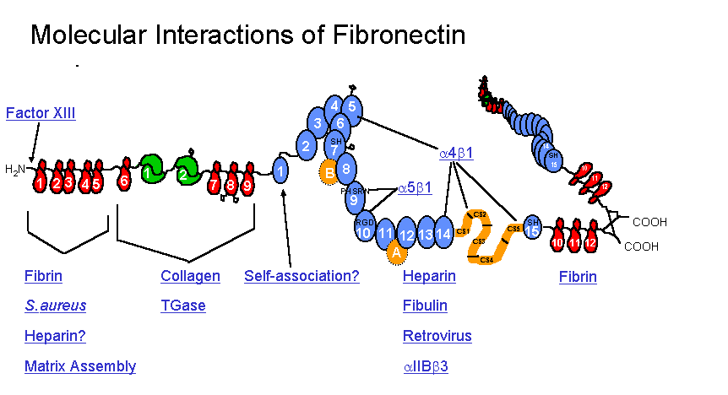
Image obtained from www.gwumc.edu/biochem/_ingham/fnreview.htm

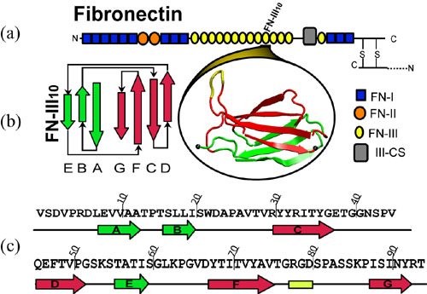
Image obtained from: www.ks.uiuc.edu/Research/fibronectin/

The yellow part is the cell binding sequence – RGD = amino acids ARGinine, GLYcine and ASPartic acid

The conformation of this protein on surfaces is very important.

So: structure of proteins is important

- Types/proportions of amino acids
- Charge of amino acids
- Hydrophobicity/hydrophilicity
- Sequence of amino acids
- Spatial arrangement - position of hydrophobic residues etc.
- Conformation

Proteins are highly important due to their tendency to deposit on surfaces in often an irreversible reaction.

Proteins adsorb for several reasons:
- Adsorption results in a lowering of the system's free energy
- Amphipathic nature of the molecules: polar/nonpolar
- Macromolecular nature and limits of solubility

How do proteins get to a surface?
Proteins tend to arrive at a surface by diffusion

If transport to the surface is fast compared to binding then rate of adsorption will be equal to the rate of binding.

If binding is faster then the rate of transport controls rate of adsorption.

How do proteins adsorb to a surface?
Protein interactions

Electrostatic bond formation between charged groups on the protein and oppositely charged surface sites

Hydrogen bonding

Further info consult "Biocompatible polymers, metals and composites. M Szycher

What sort of proteins are we talking about?
Soluble proteins found in blood plasma are those primarily involved in adsorption

They differ from insoluble proteins in:

- Diffusivity
- Less regular amino acid composition
- Less regular 3 dimensional structure

The amino acid sequence is key to protein diversity

Due to properties of amino acid side chains (see handout) such as:
Charge
Polarity

Isoleucine is very hydrophobic
Arginine is very hydrophilic

The diversity of side chains and proportions of amino acids in each protein leads to diverse solubilities and surface interactions

Polar=hydrophilic, nonpolar=hydrophobic

Under physiological conditions soluble proteins tend to:

- Have a very distinct 3 dimensional structure, due to formation of non covalent bonds
- Be generally spherical or globular
- Hydrophobic residues tend to be inside the structure
- Hydrophilic residues tend to be outside of the general structure

Therefore residues hidden inside may not be available to bond with the surface of the substrate

What about non-physiological conditions?

Physiological =

0-45C
pH5-8
Approx. 0.15M ionic strength

Denaturation effects conformation, function etc.

Fibronectin and albumin adsorption and effect on cell attachment

Fibronectin: fibroblasts
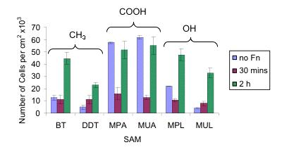
Fibronectin: keratinocytes
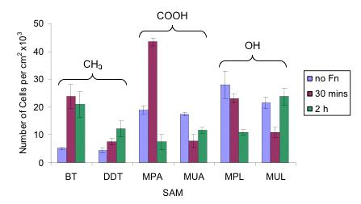

Albumin: fibroblasts
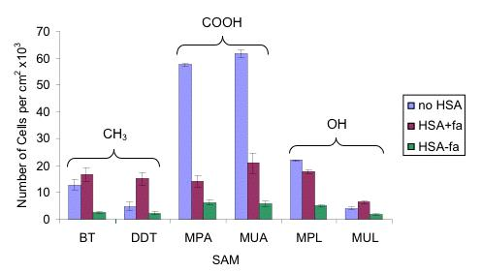
Albumin: keratinocytes
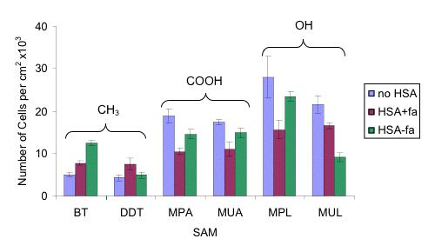
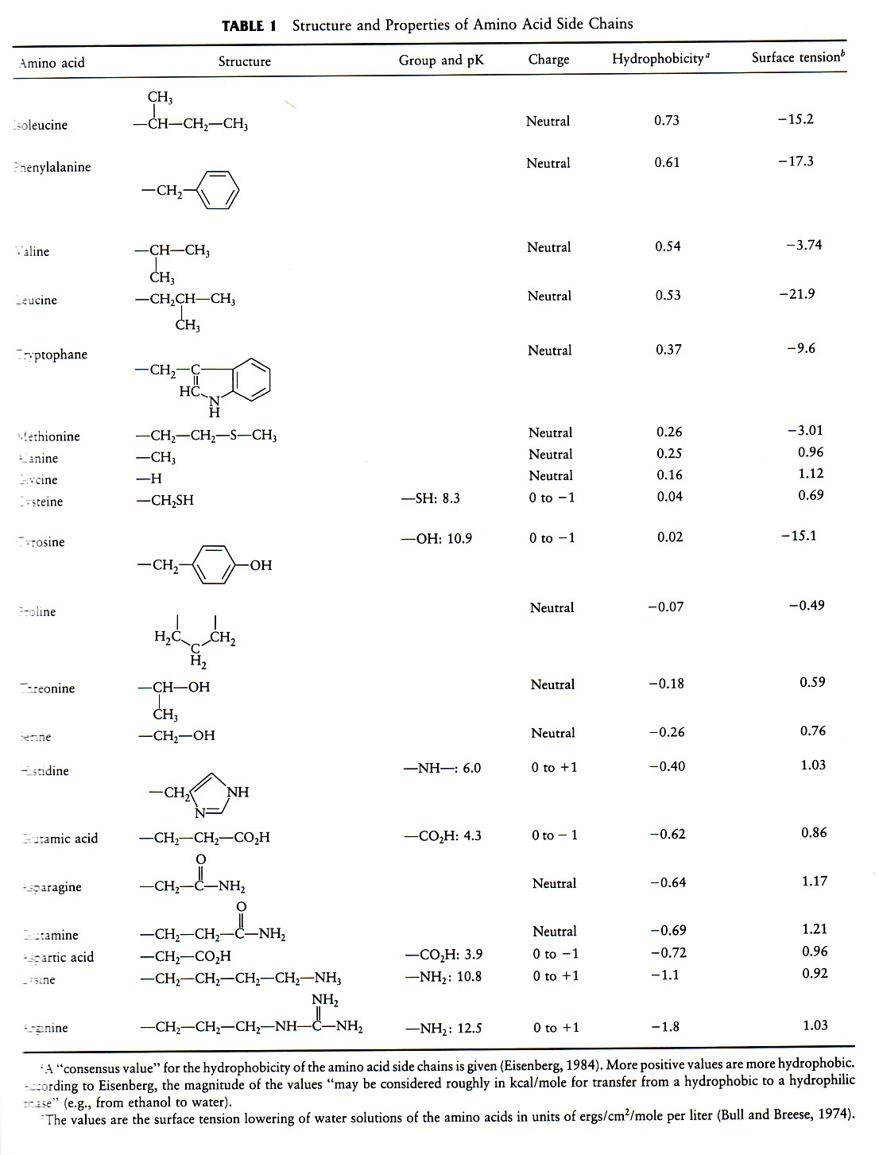
Isoleucine
Valine
Phenylalanine
Leucine
Tryptophane
Methionine
Alanine
Glycine
Cysteine
Tyrosine
Proline
Threonine
Serine
Histidine
Glutamic acid
Asparagine
Glutamine
Aspartic acid
Lysine
Arginine

