_______________________________________________________________

Module ML2921 Tissue Interactions and Biocompatibility

Lecture 1 Protein Adsorption 26/09/05
_______________________________________________________________________

What is biocompatibility?

“not having a toxic or injurious effect on biological systems”

“the ability of a material to perform with an appropriate host response in a specific application”

“a material intended to interface with biological systems to evaluate, treat, augment, or replace a tissue, organ or function of the body”

Protein adsorption:

TIMESCALE EVENT
<1 second Proteins adsorb
Seconds-minutes Protein monolayer
Minutes Cells arrive

Cells respond to specific proteins

So therefore?

What determines whether proteins adsorb?

What determines whether cells then attach?

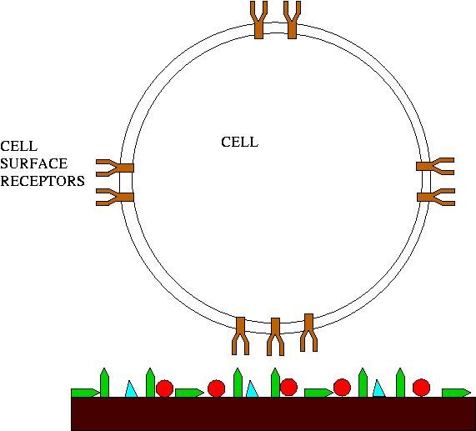

What is next stage after cells adhere?

Proteins can have complex structures
For example the fibronectin molecule:

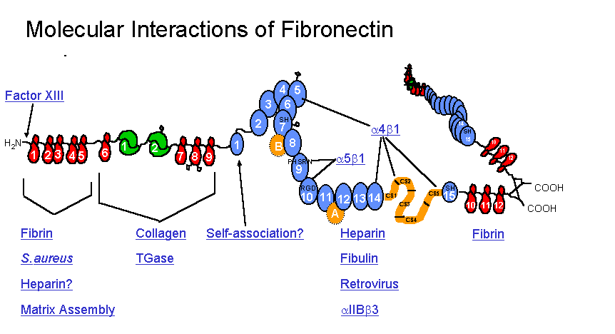
Image obtained from www.gwumc.edu/biochem/_ingham/fnreview.htm

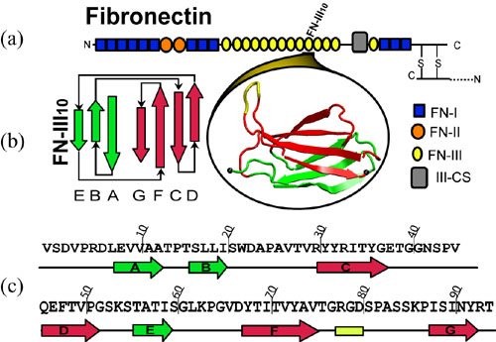
Image obtained from: www.ks.uiuc.edu/Research/fibronectin/

So: structure of proteins is important

- Types/proportions of amino acids
- Charge of amino acids
- Hydrophobicity/hydrophilicity
- Sequence of amino acids
- Spatial arrangement - position of hydrophobic residues etc.
- Conformation

Proteins are highly important due to their tendency to deposit on surfaces in often an irreversible reaction.

Proteins adsorb for several reasons:
- Adsorption results in a lowering of the system's free energy
- Amphipathic nature of the molecules: polar/nonpolar
- Macromolecular nature and limits of solubility

Proteins tend to arrive at a surface by diffusion

If transport to the surface is fast compared to binding then rate of adsorption will be equal to the rate of binding.

If binding is faster then the rate of transport controls rate of adsorption.

Protein interactions

Electrostatic bond formation between charged groups on the protein and oppositely charged surface sites
Hydrogen bonding

Further info consult "Biocompatible polymers, metals and composites. M Szycher

Soluble proteins found in blood plasma are those primarily involved in adsorption

They differ from insoluble proteins in:

- Diffusivity
- Less regular amino acid composition
- Less regular 3 dimensional structure

The amino acid sequence is key to protein diversity

Due to properties of amino acid side chains (see handout) such as:
Charge
Polarity

Isoleucine is very hydrophobic
Arginine is very hydrophilic

The diversity of side chains and proportions of amino acids in each protein leads to diverse solubilities and surface interactions

Polar=hydrophilic, nonpolar=hydrophobic

Under physiological conditions soluble proteins tend to:

- Have a very distinct 3 dimensional structure, due to formation of non covalent bonds
- Be generally spherical or globular
- Hydrophobic residues tend to be inside the structure
- Hydrophilic residues tend to be outside of the general structure

Therefore residues hidden inside may not be available to bond with the surface of the substrate

What about non-physiological conditions?

Physiological =

0-45C
pH5-8
Approx. 0.15M ionic strength

Fibronectin and albumin adsorption and effect on cell attachment

Fibronectin: fibroblasts
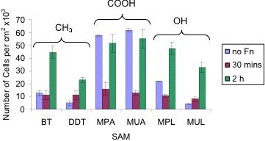
Fibronectin: keratinocytes
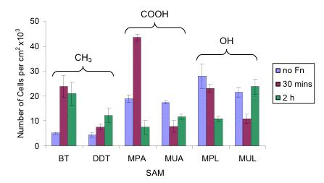
Albumin: fibroblasts
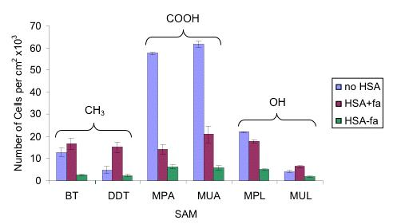
Albumin: keratinocytes
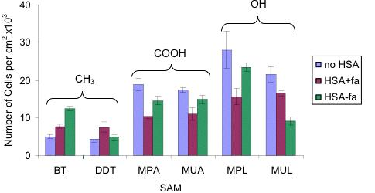

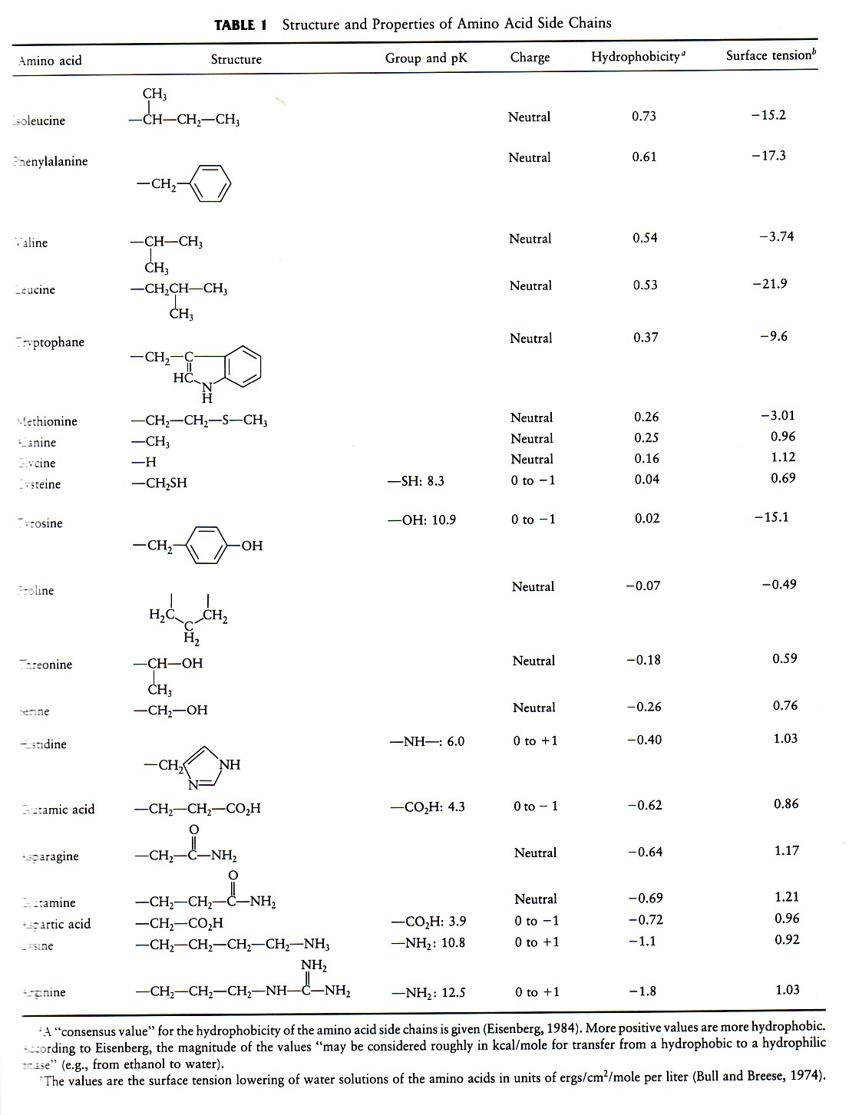
Isoleucine
Phenylalanine
Valine
Leucine
Tryptophane
Methionine
Alanine
Glycine
Cysteine
Tyrosine
Proline
Threonine
Serine
Histidine
Glutamic acid
Asparagine
Glutamine
Aspartic acid
Lysine
Arginine

