Converting SPSS format data for use in R

This guide is for transforming data from this type of format:
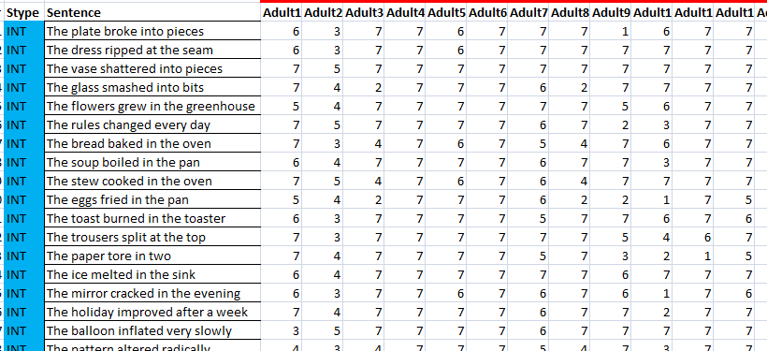

Into the following format, e.g. for analysis in R:

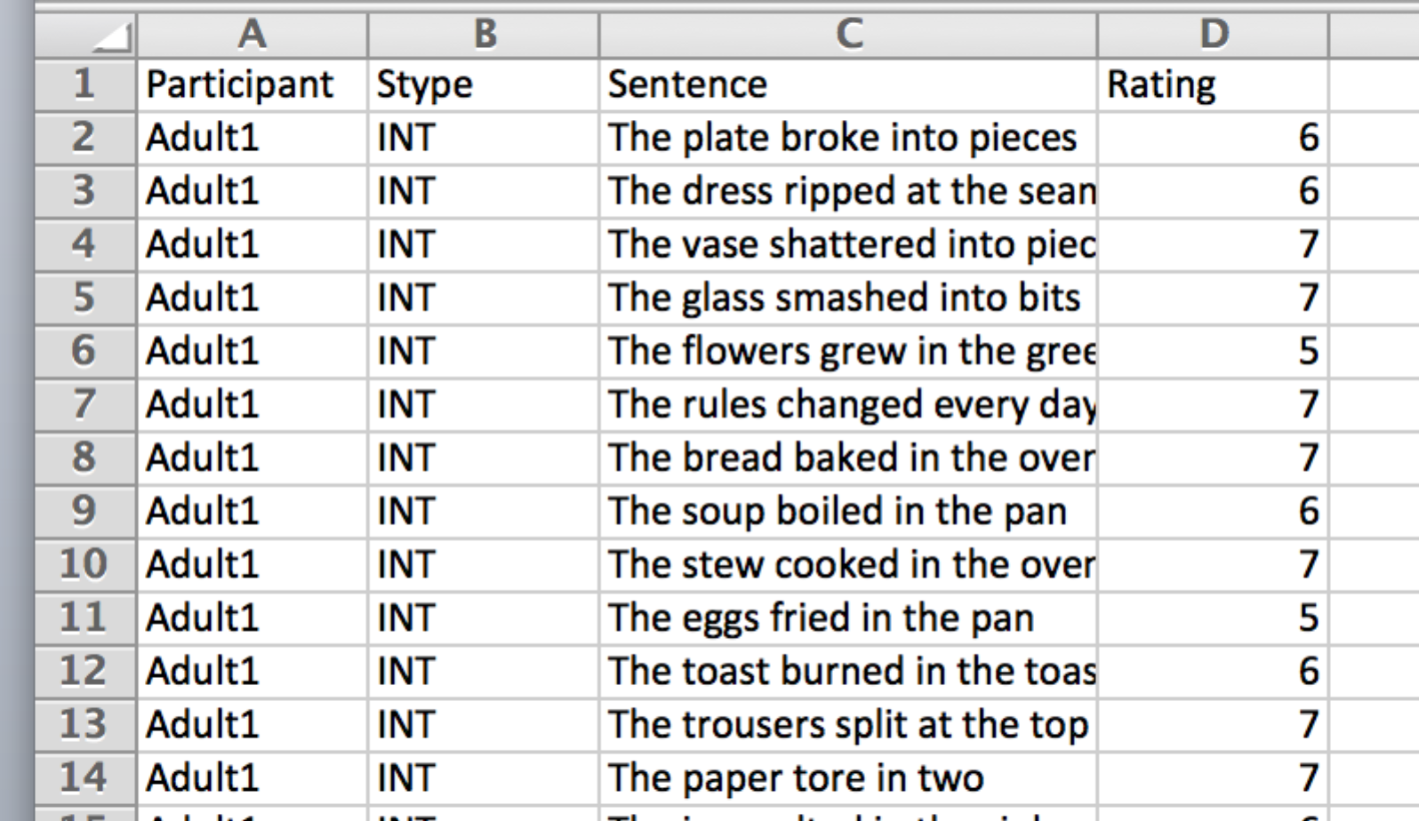

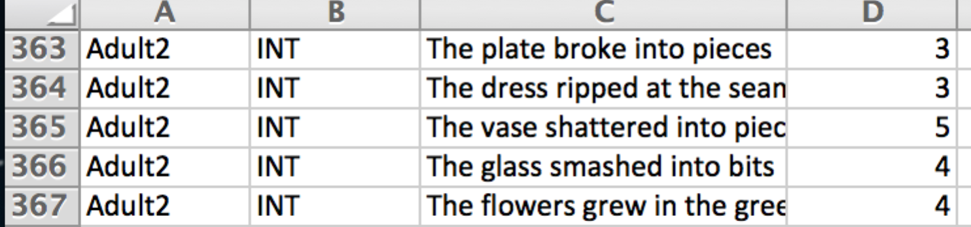

By the way, these data are adult grammaticality judgments of the sentences shown on a 7-point scale (1=highly unacceptable, 7=highly acceptable).

- [You can skip this step if you already have an SPSS dataset] Create an Excel spreadsheet from the original data file with participant names as column headers. ‘NA’ values should be replaced by ‘0’ and all formatting should be removed. There must be no spaces in column headers. Open up SPSS and then load this Excel spreadsheet (you’ll need to change the options in the dialogue box to allow SPSS to “see” Excel files).
- Go to Data → Restructure...
- In the Wizard, select the following options:
  - Restructure selected variables into cases; click Next.
  - One variable group; click Next.
  - In ‘Case Group Identification’, select ‘Use selected variable’ from the dropdown menu. Add the variable that constitutes a case (here “Sentence”).
  - In ‘Variables to be transposed’, add all participants; click Next.
  - One index variable; click Next.
  - Variable names as index values; click Next.
  - In ‘Handling of Variables not Selected’ choose ‘Keep and treat as fixed variable(s)’.
  - In ‘System Missing or Blank Variables in all Transposed Variables’ choose ‘Create a case in the new file; click Next.
  - Restructure the data now; click Finish.
  - Press OK if a dialogue box pops up.

- Check the restructured data look OK and save the file. This can then be exported to Excel or saved directly as a .csv file for use in R.

